E-Signature User Manual

Version -----

Prime Bank PlC.

**User Login**

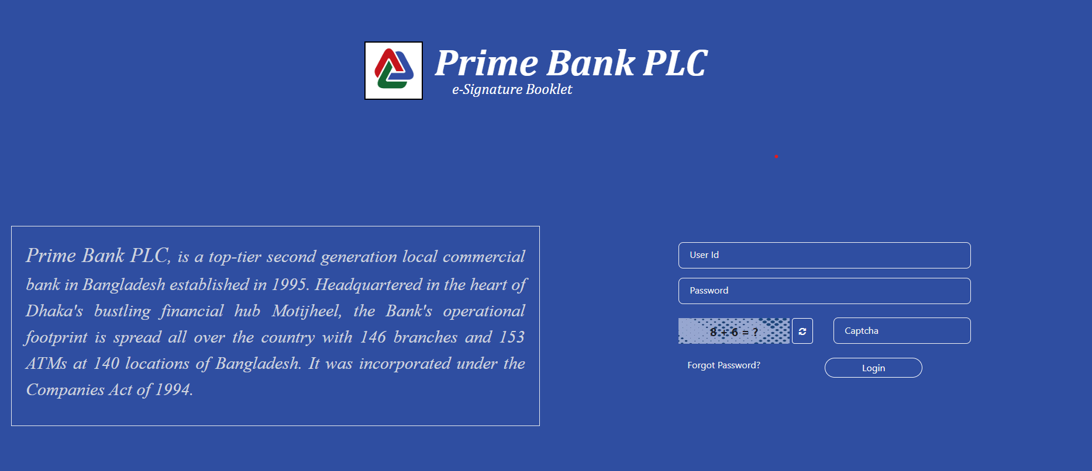

Login page:

Login with AD user Id, password and captcha.

**Forgot Password**

on Click "Forgot Password" text.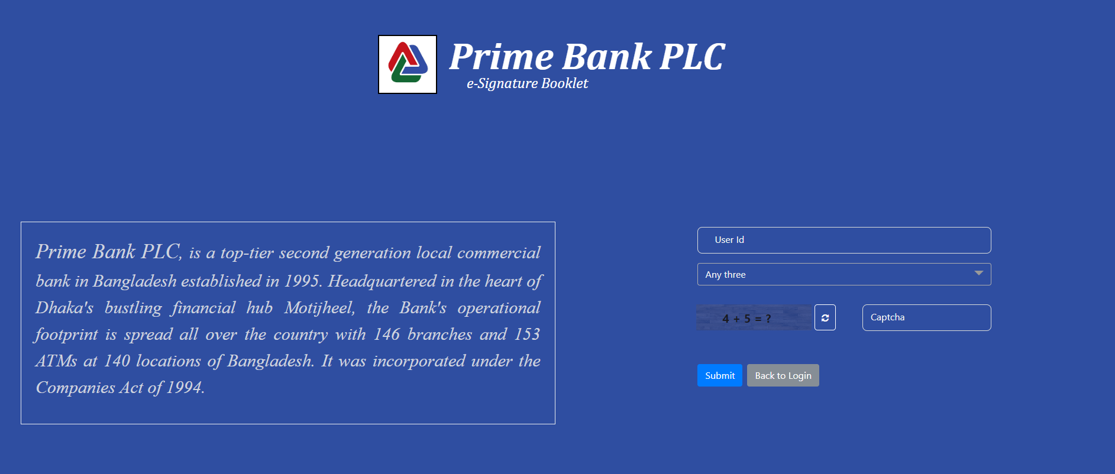

Forgot Password page:

Enter user ID, password, and captcha, then click the submit button.

**Dashboard:**

Assign role permission user is getting this dashboard.

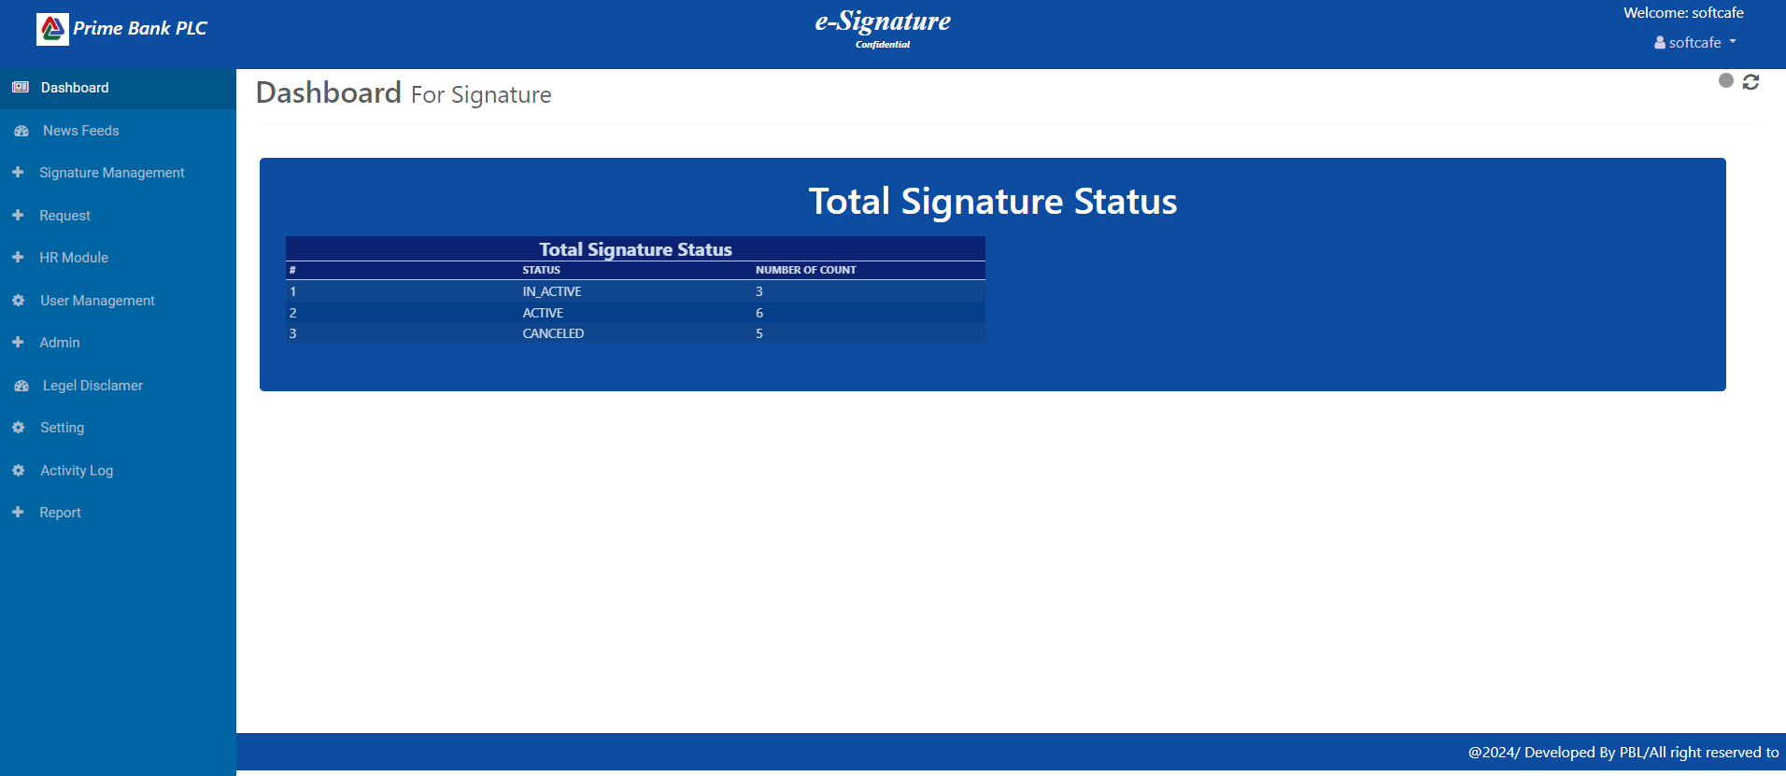

**Profile:**

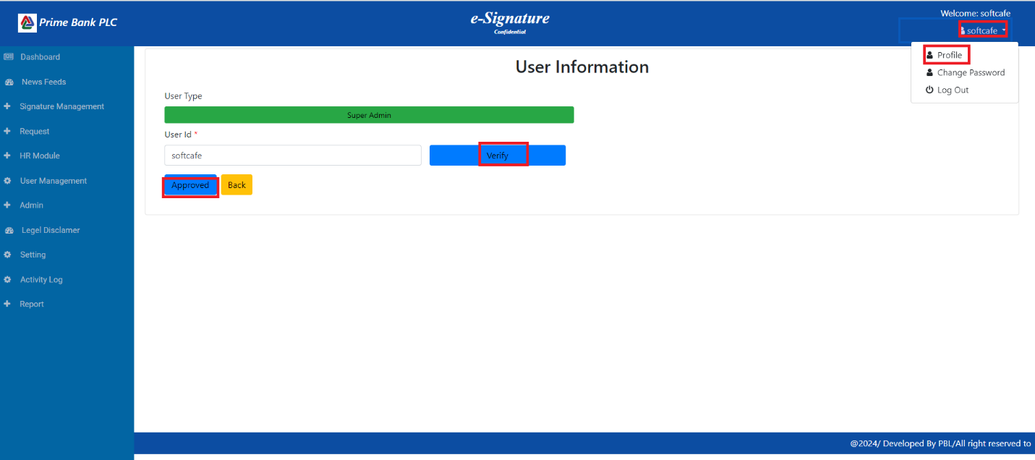

Profile pge:

1. Click Profile to open the page
2. Select the User ID and click on the Verify button.
3. Click on the Approved button.

**Change Password:**

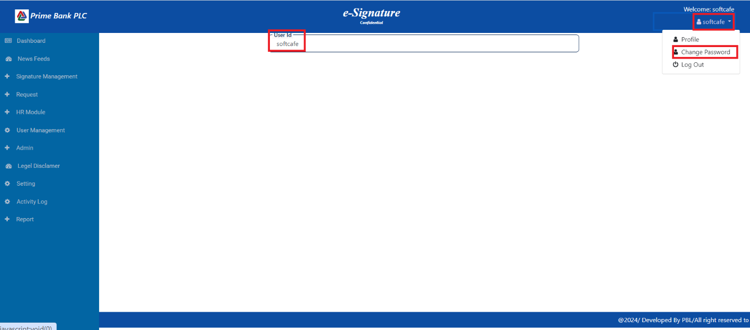

**Admin:   
User List:**

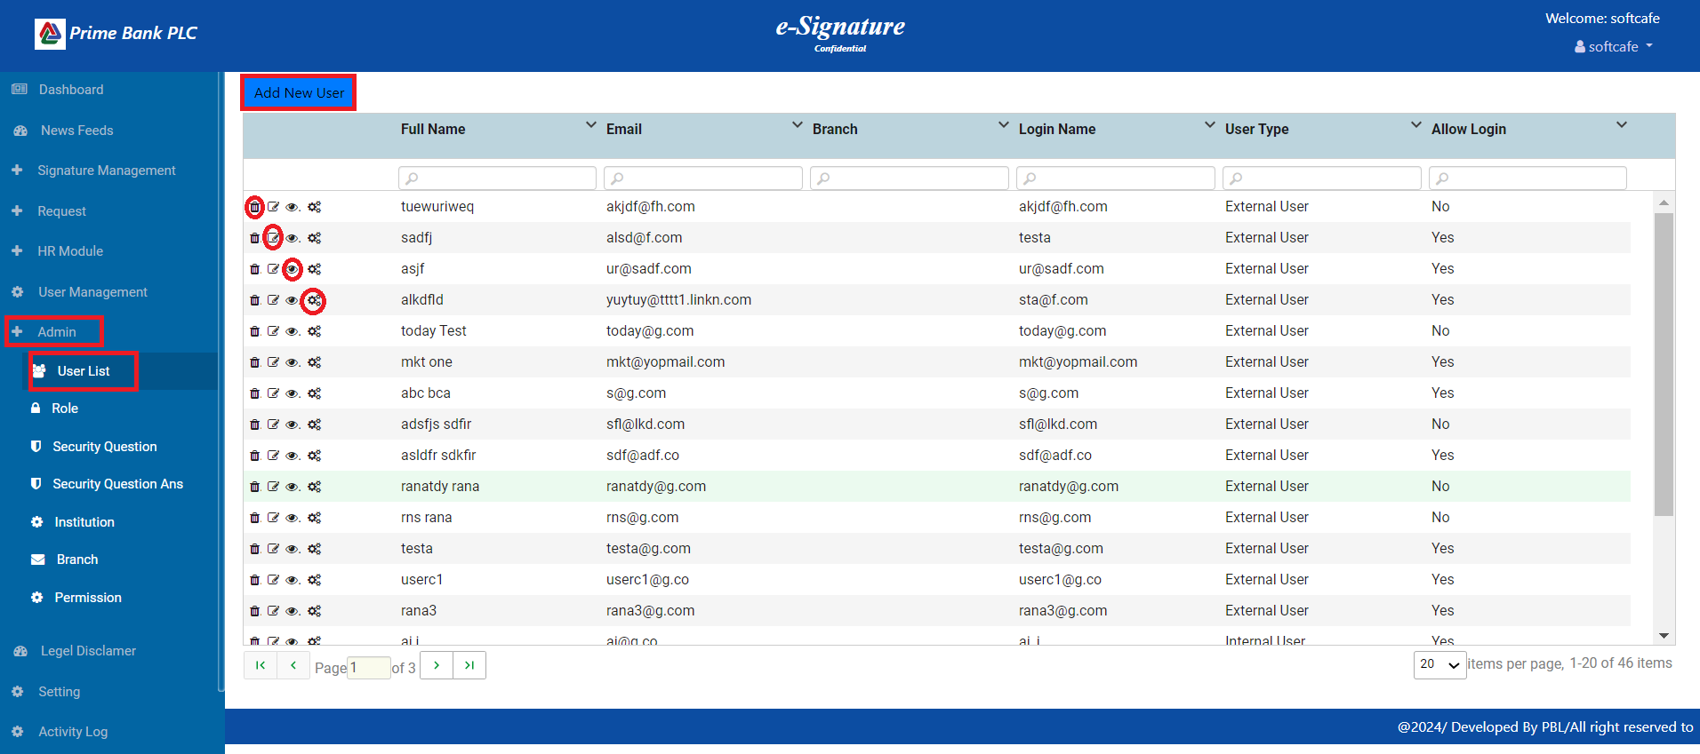

1. First, click the Admin menu, then click the User List menu to display all user data.
2. Click on the "Add New User" button after opening the User Information page.
3. Click on the delete icon, then delete a single user's information.
4. Click on the Edit icon, then update user Information
5. Click on the view icon to show the user all information.
6. Click on the 'manage-role-icon' to show the user role.

**Add New User:**

**Internal User**

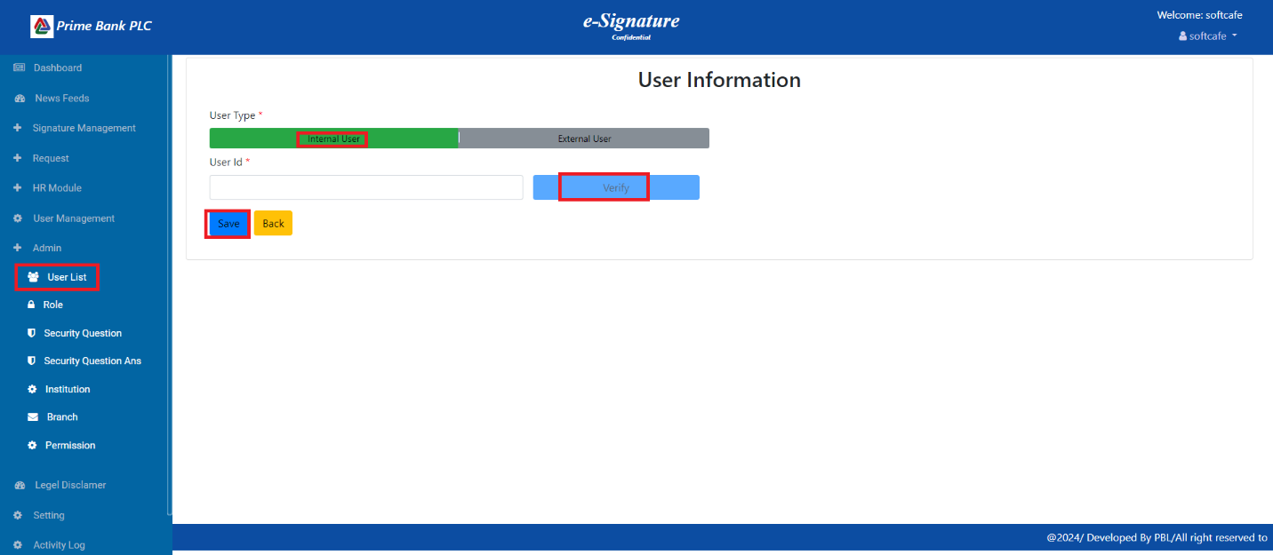

1. Click on the internal User type, then input the User ID.
2. Click on the Verify button after showing the user details.
3. All data must be entered before clicking the Save button.

**External User**

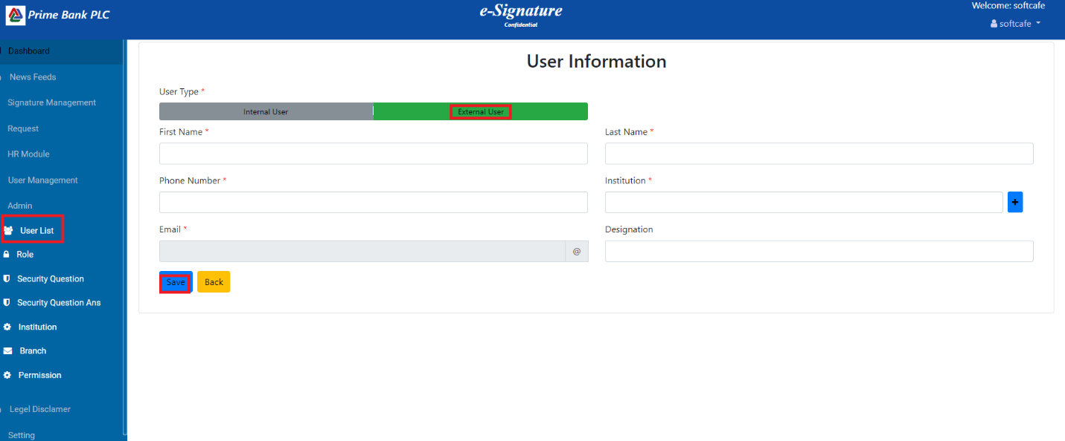

1. Click on the "External User" type, then input data in all fields and click the "Save" button.

**Role:**

**Add Role**

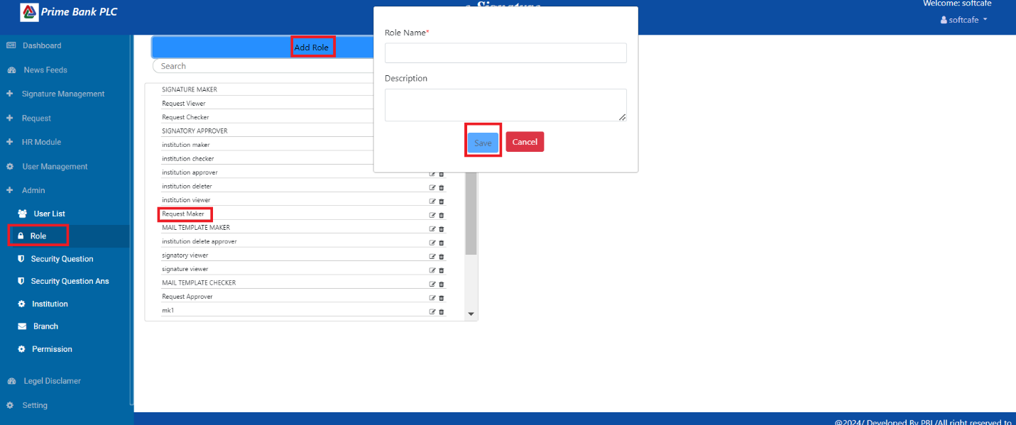

1. Click on the Role menu then show the role.
2. Click on the "Add Role" button. After the popup opens, enter the Role Name and Description, then click the "Save" button.

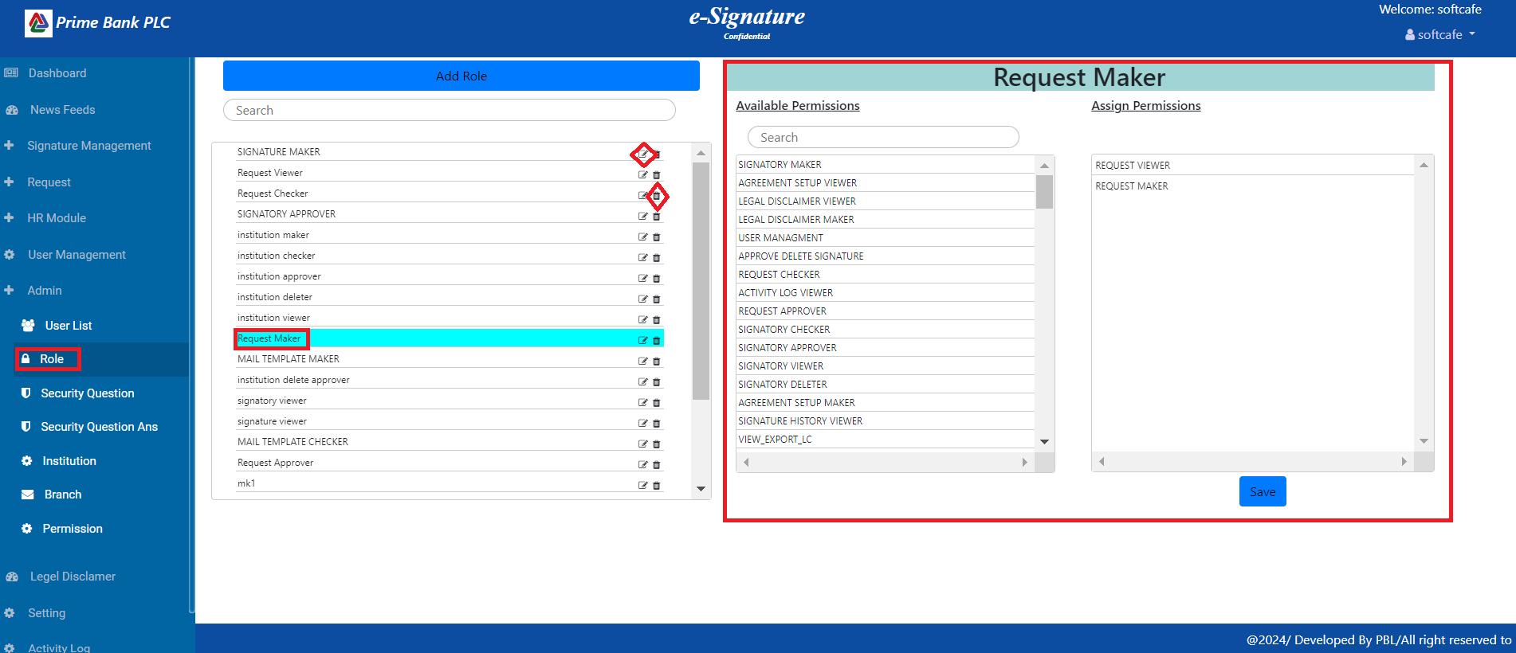

1. Click any Role and Assign Permissions
2. Click on the edit icon, then update Role.
3. Click on the Delete icon, then delete Role.

**Security Question:**

**Add Question**

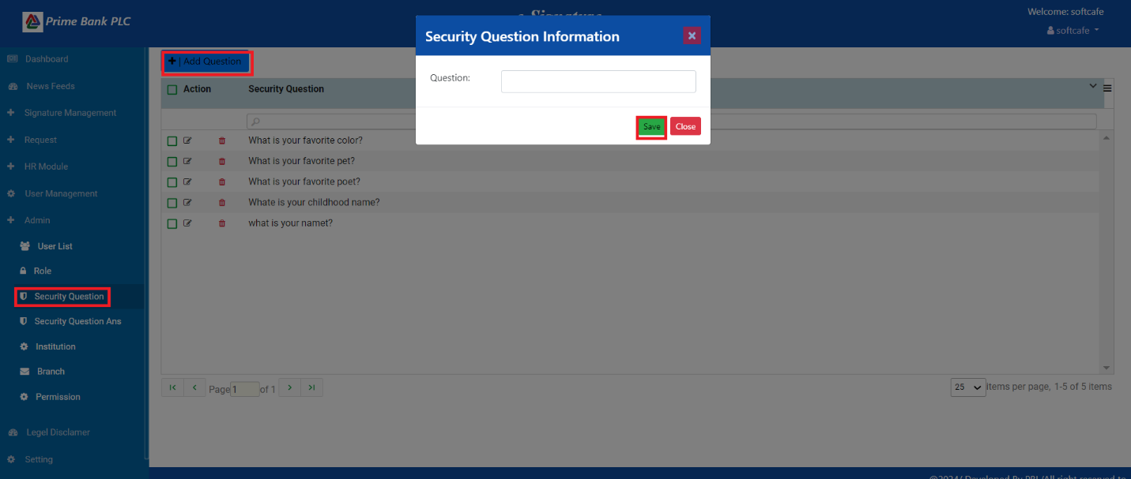

1. Click on the Security Question menu, then click on the Add Question button, input the question field, and finally click on the Save button.

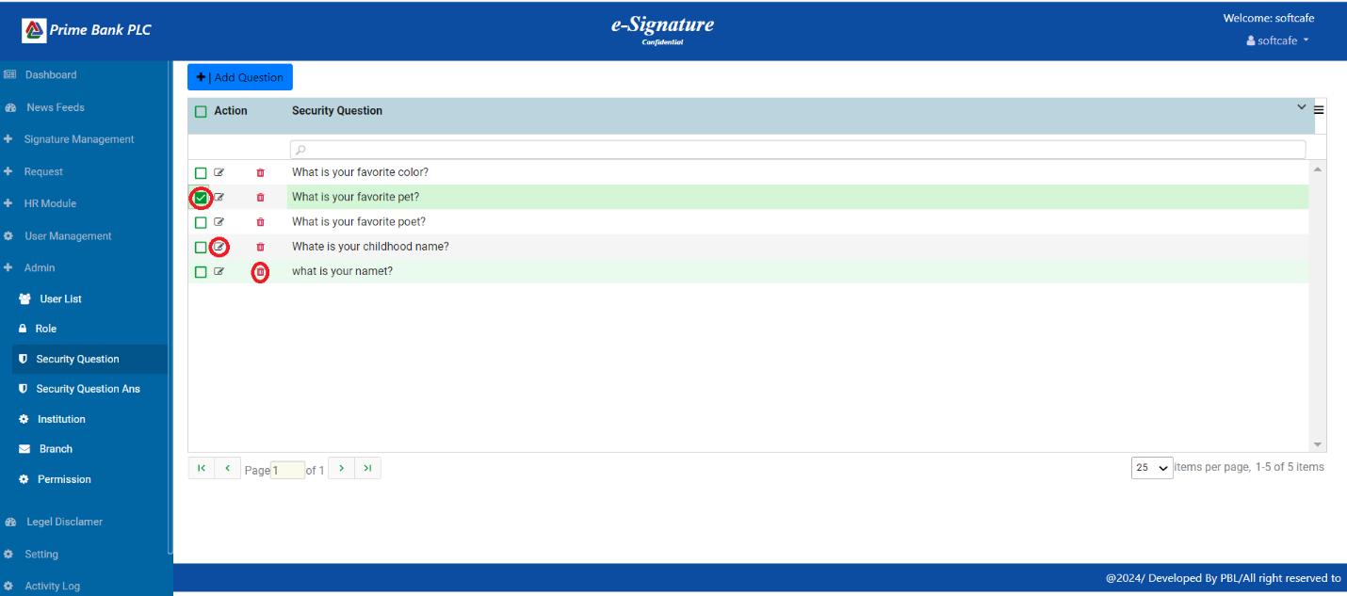

1. Click on the edit icon, then update Question.
2. Click on the Delete icon, then delete Question.

**Security Question Answer:**

**Add Question Answer**

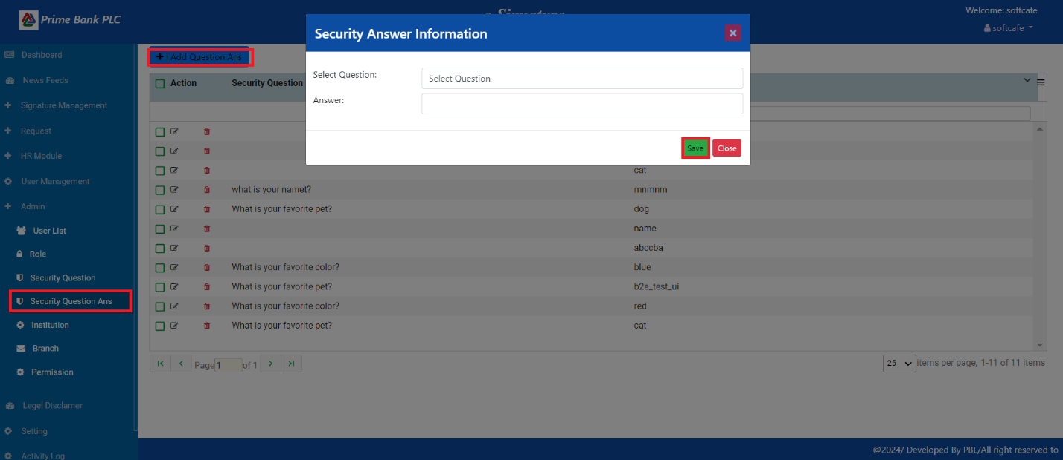

1. Click on the Security Question Answer menu, then click on the Add Question Answer button, Select the question field, input Answer, and finally click on the Save button.

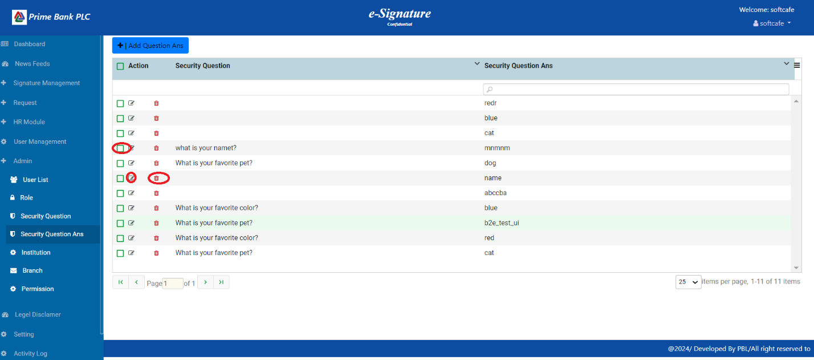

1. Click on the edit icon, then update Question Answer.
2. Click on the Delete icon, then delete Question Answer.

**Institution:**

**Add Institution**

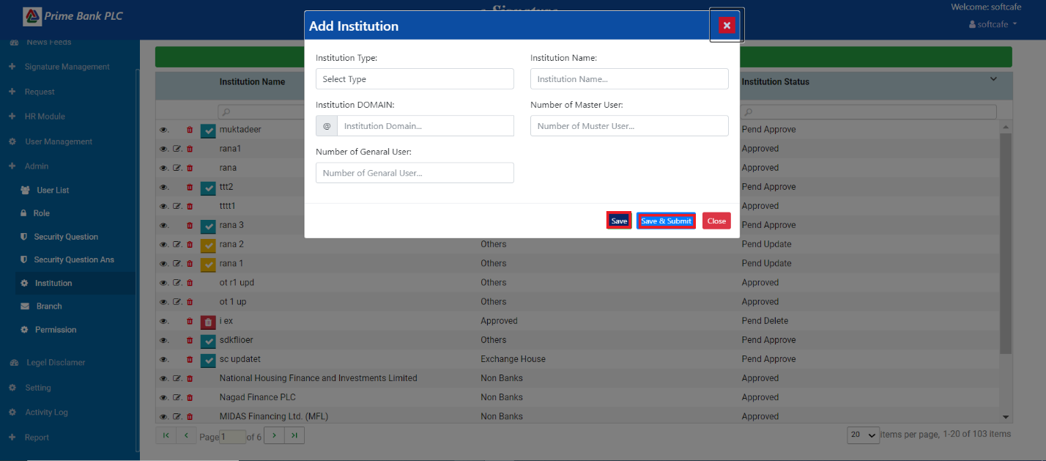

1. First, click the 'Institution' menu, then click on the 'Add institution' button to open the popup. Input all the fields, and finally, click on the 'Save' button.
2. Click on the 'Save & Submit' button to save all data and authorize another person.

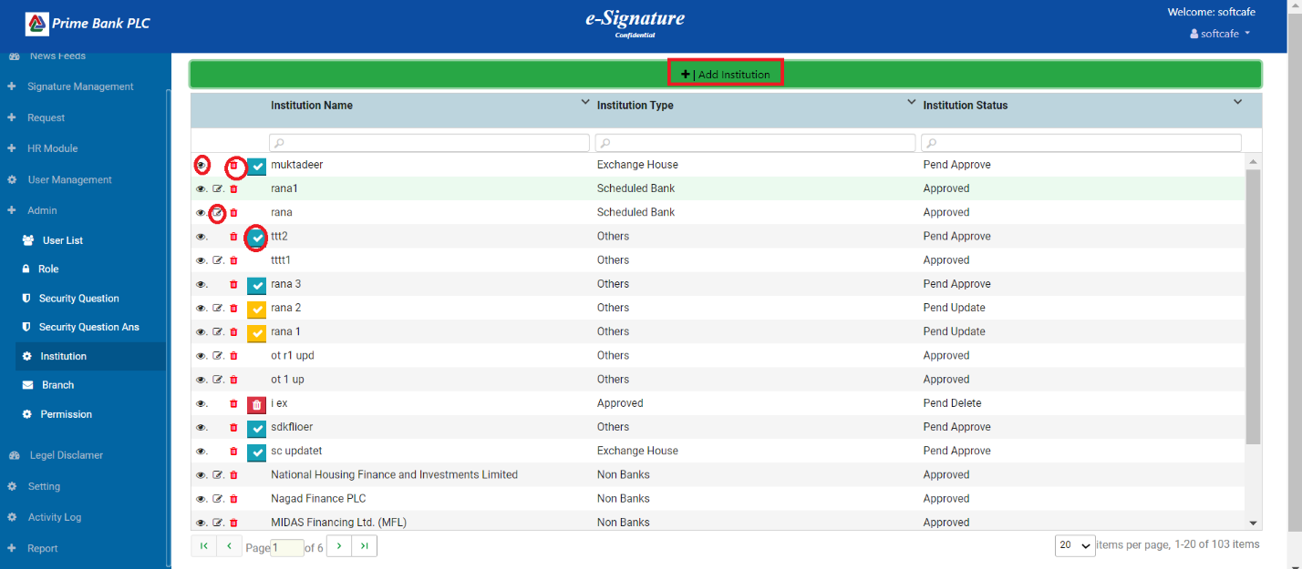

1. Click on the 'Institution' menu to show the list of all institutions.
2. Click on the view icon to show single institution data.
3. Click on the edit icon to update the institution data.
4. Click on the delete icon, then delete the single institution.
5. Click on the check mark, then authorize the institution.

**Branch:**

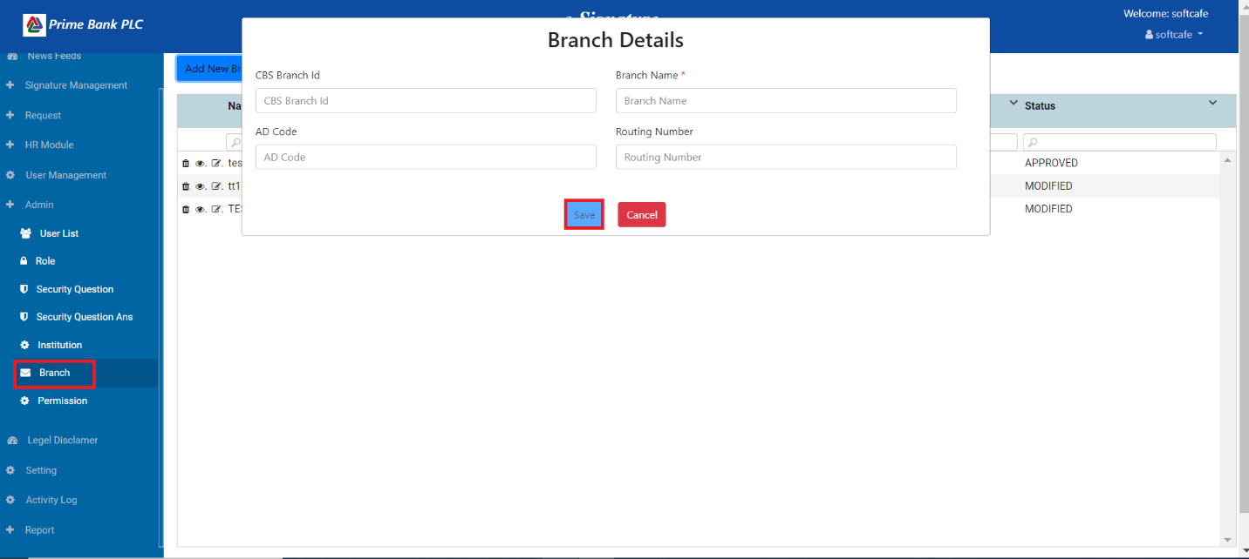

1. First, click the Branch menu, then click on the 'Add New Branch' button to open the Branch Details page.
2. Do input data in all fields and then click the Save button.

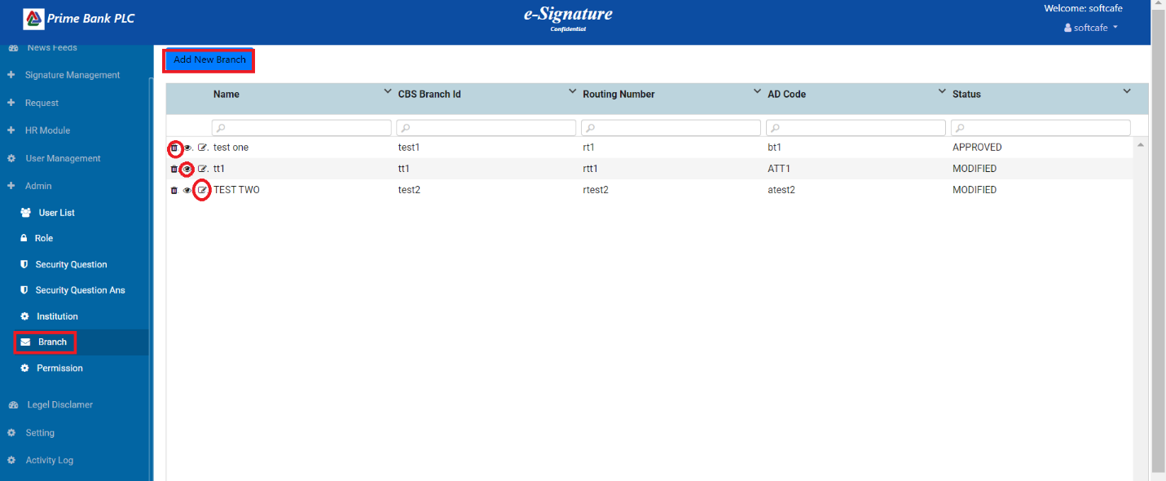

1. Click on the Branch menu to display the Branch data.
2. Click on the delete icon, then delete single branch data.
3. Click on the view icon to show single branch data, then click on the approved button.
4. Click on the edit icon to update the branch data.

**Permission:**

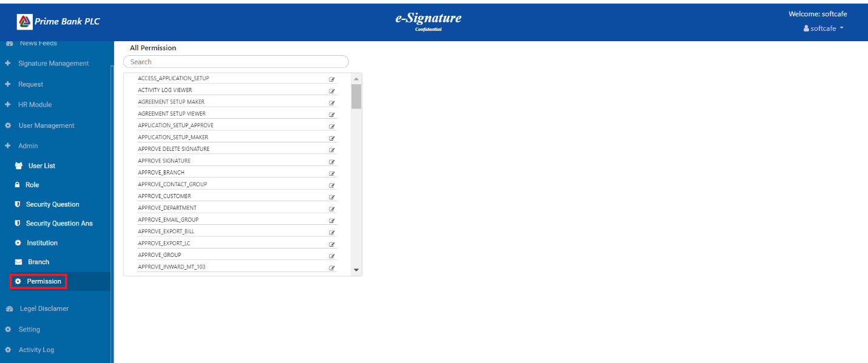

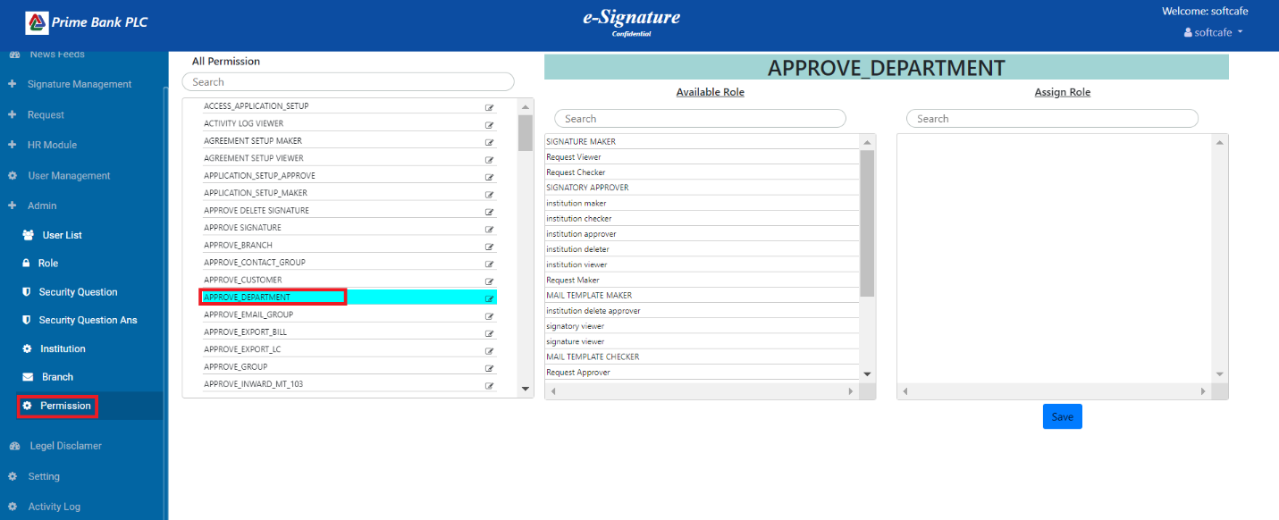

1. User can drag & drop role (available role to assign role), Approve Role has permission to access save button.
2. Each user is granted permissions separately

**Signature Management:**

**UpLoad**

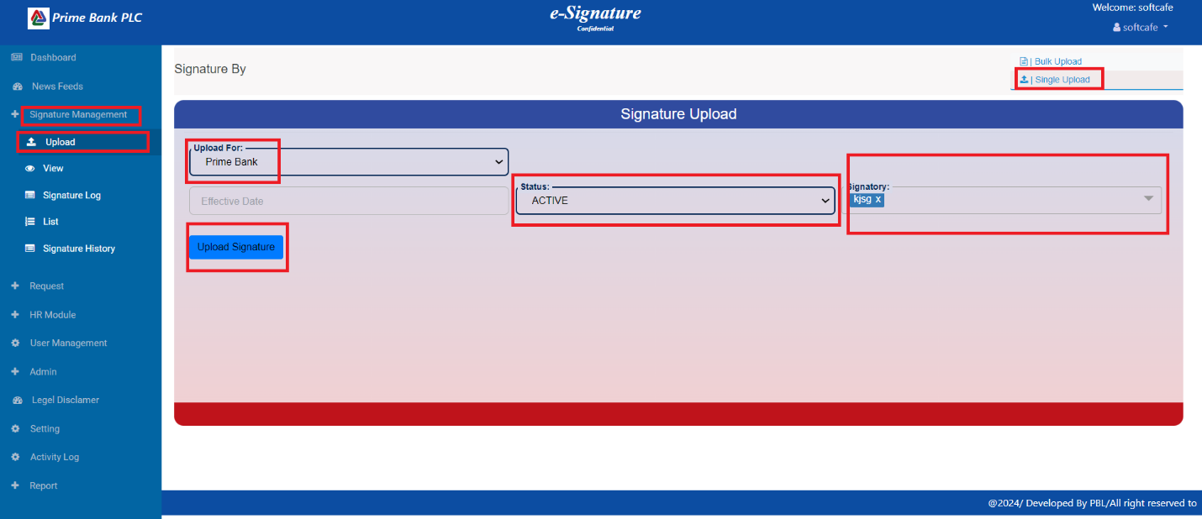

1. First, the user clicks on the Signature Management menu, then they click on the Upload menu to select the Single Upload button, which opens the Signature upload page.
2. Please select 'Upload' for the field, choose 'Status', and then select 'Signatory'. Finally, click the 'Upload Signature' button.

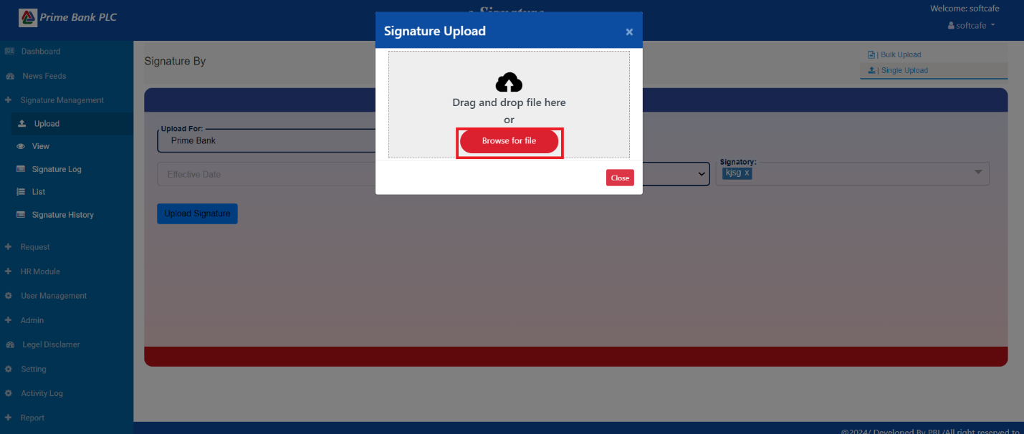

1. The user clicked on "Browse for file.

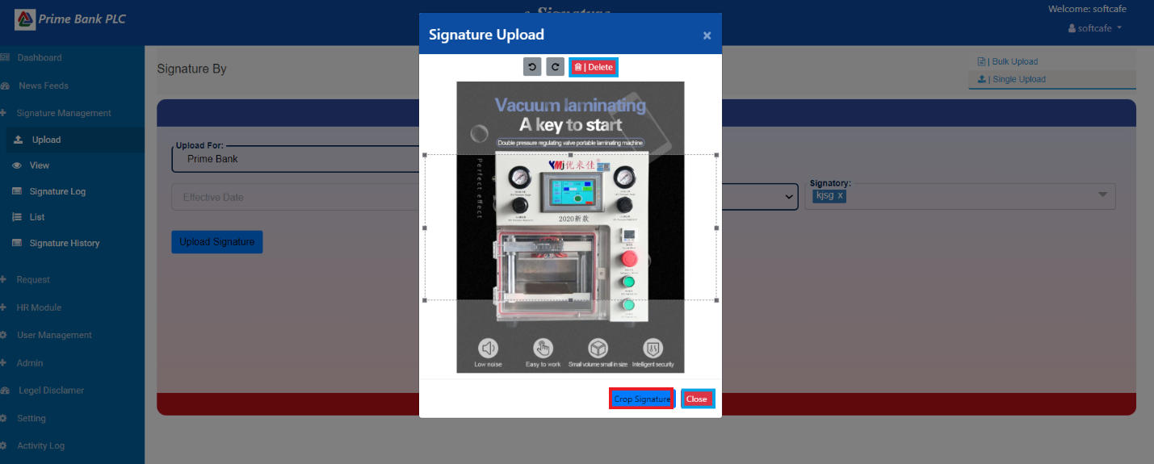

1. user clicks on the "Crop Signature" button.

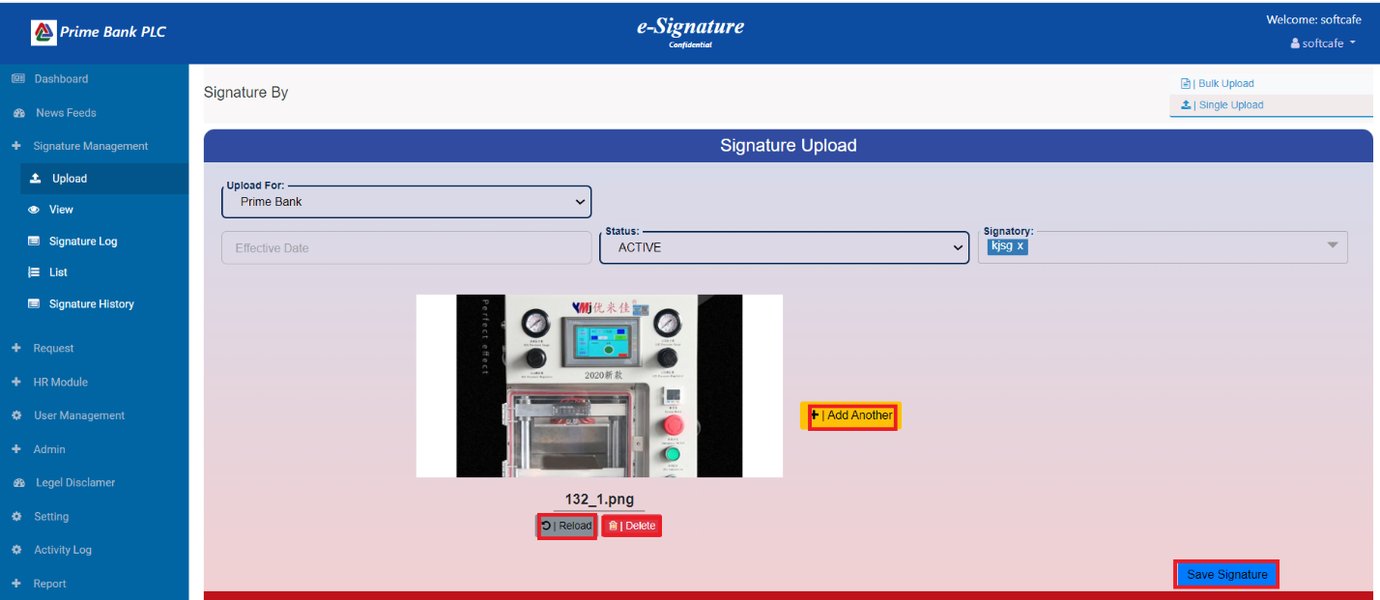

1. The user wants to upload more signatures. Click on the 'Add Another' button then Click on Sava Signature button.
2. To delete the signature, click the delete button.
3. To Reload the signature, Click the Reload button.

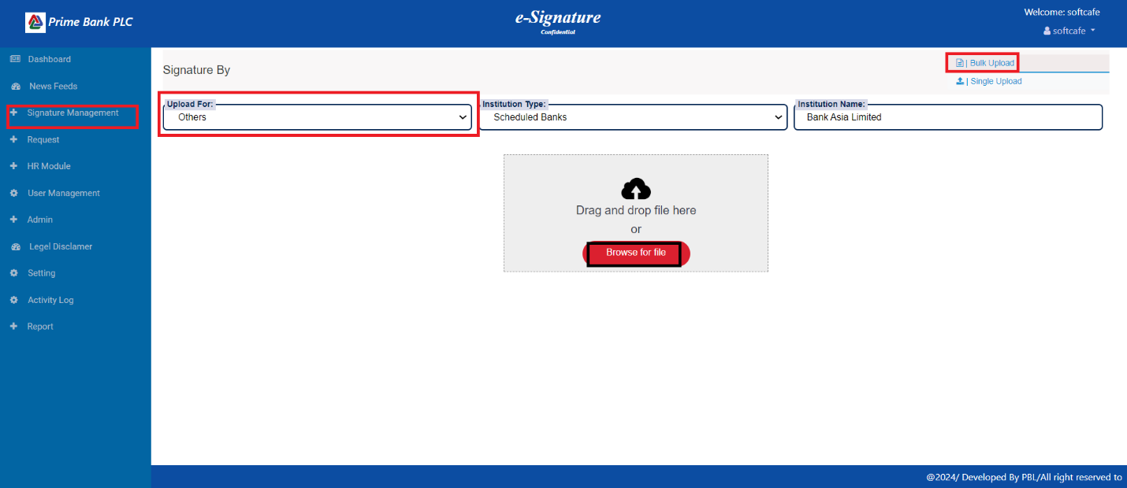

1. First, the user clicks on the Signature Management menu, then they click on the Upload menu to select the Bulk Upload button, which opens the Signature upload page.
2. Please select 'Upload' for the field, choose ' Institution Type', and then select ' Institution Name'. Finally, click the 'Browse for file ' button then Choose the file.

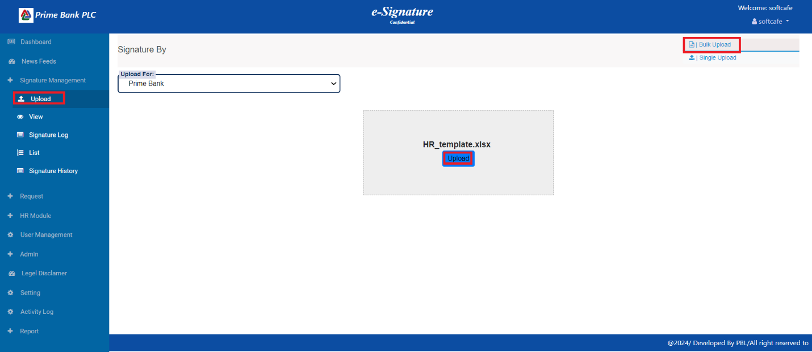

1. User clicks on the Upload button, and then the file upload is complete.

**View:**

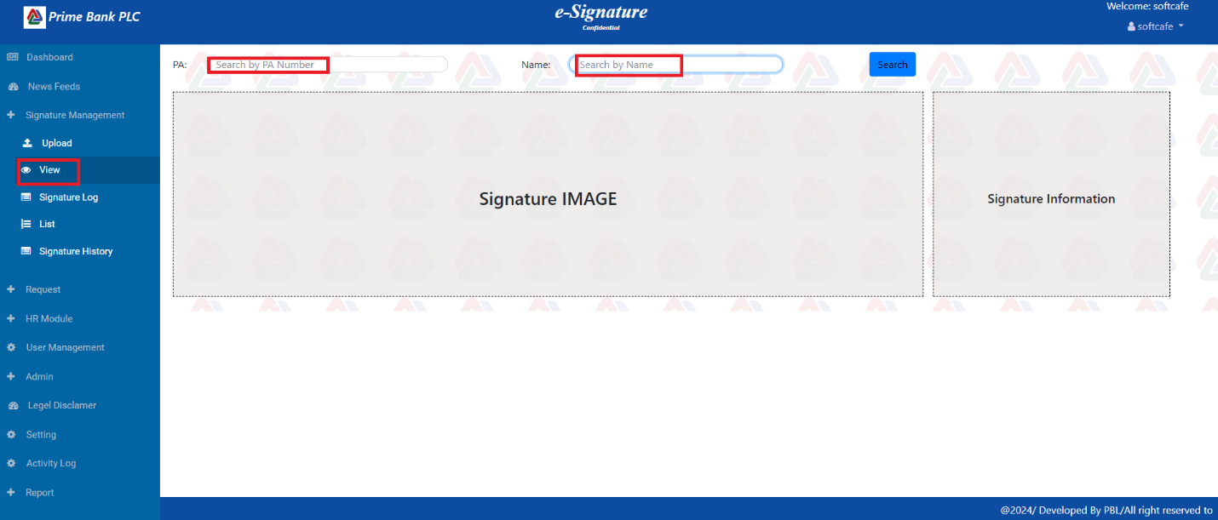

1. The user first clicks the View menu, then inputs the PA number or name, and clicks the Search button. Finally, the signature and signature information are displayed.

**Signature Log:**

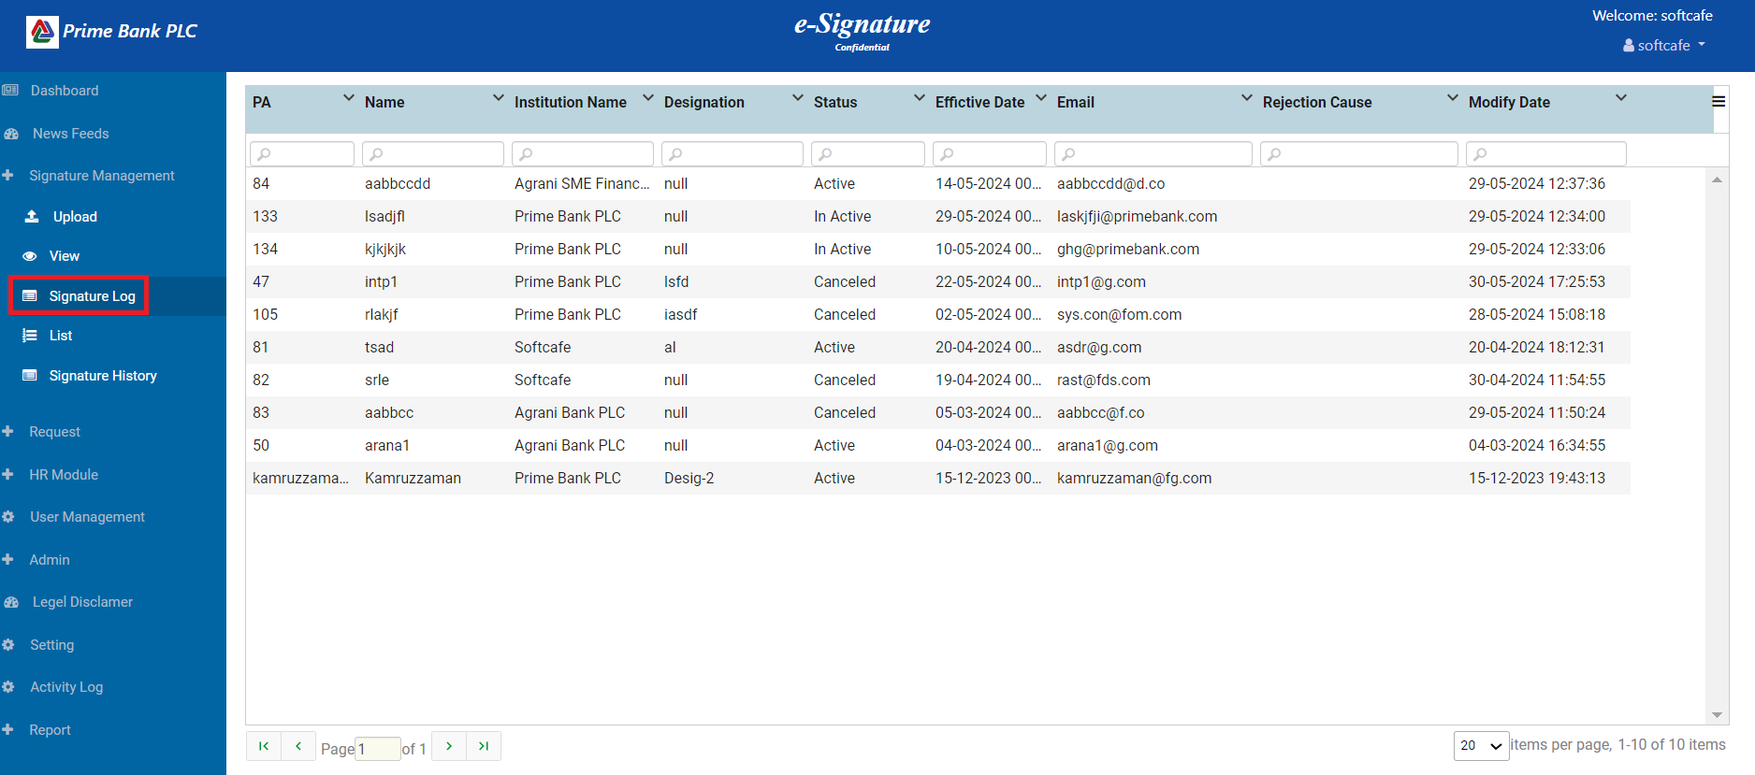

1. The user clicks on Signature Log to show all Signature Information.

**List:**

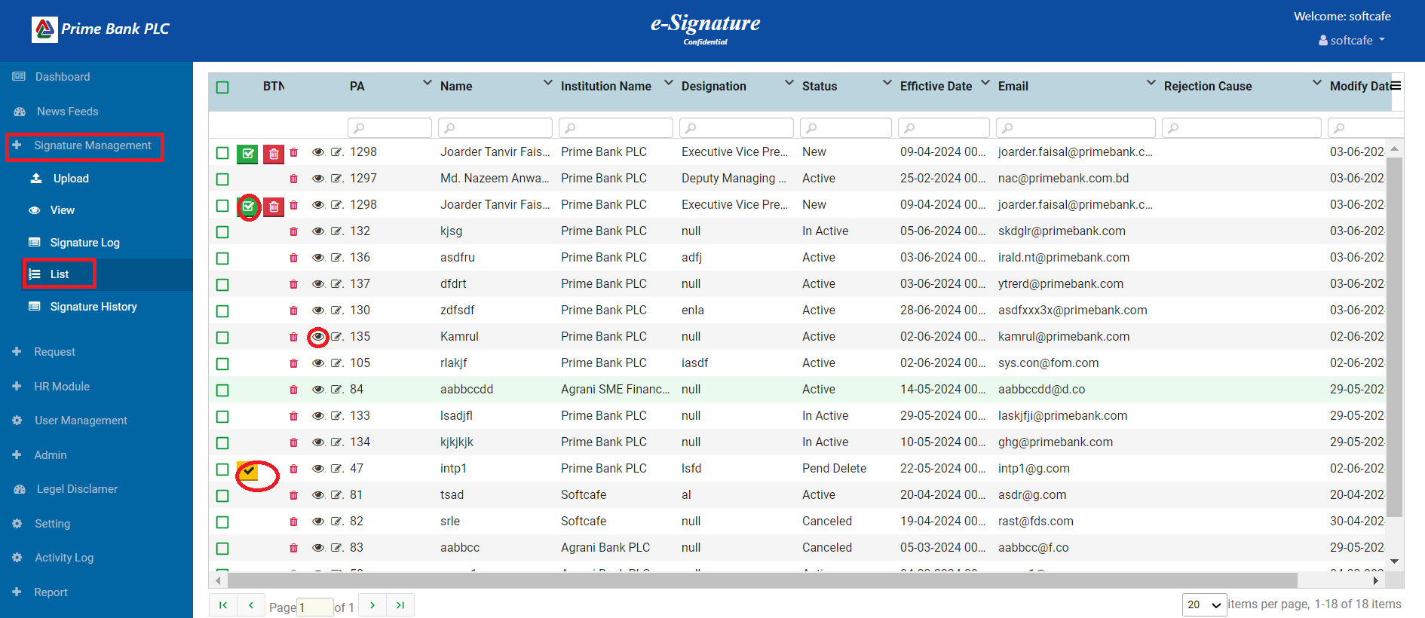

1. First, the user clicks on the Signature Management menu, then clicks on List to show all signature data.
2. The user clicks on the tick mark to approve the uploaded signature.
3. When the user clicks on the view icon, a single piece of information is displayed.

**Signature History:A**

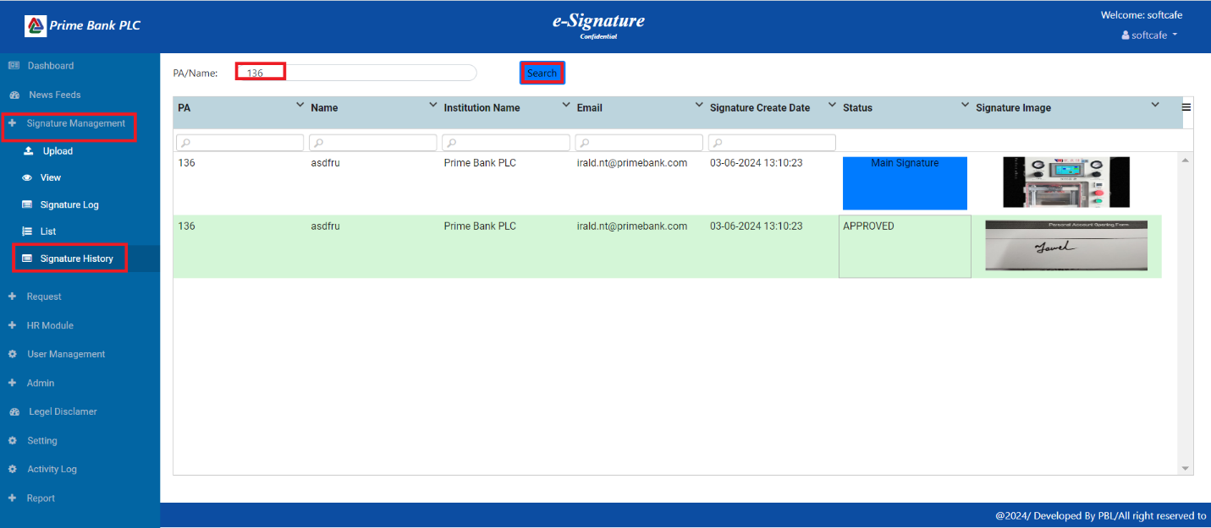

1. The user clicks on Signature History, then searches for PN/name to display the signature data.

**Request :**

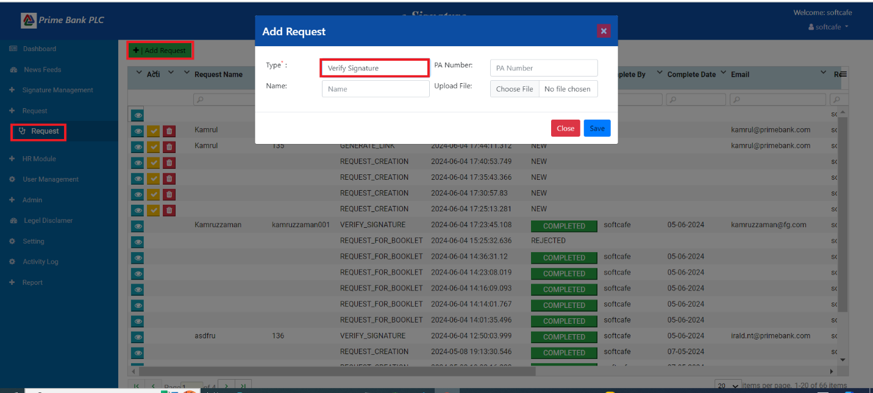

1. The user clicks on the Request menu, then clicks the Add Request button, selects the Type, inputs all data, and clicks the save button.

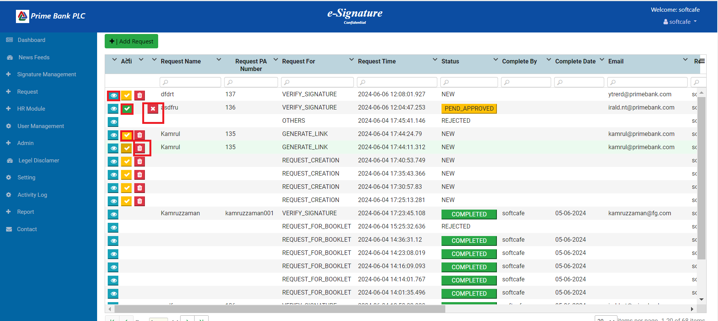

1. When the user clicks on the view icon, display the request data.
2. user clicked on the yellow tick mark to approve the request.
3. user clicked on the green tick mark to authorize the request, and the email is sent.
4. User click on the delete icon then delete Request.
5. When the user clicks on the cross icon, the request is rejected, an email is sent.
6. **Temporary Link :**

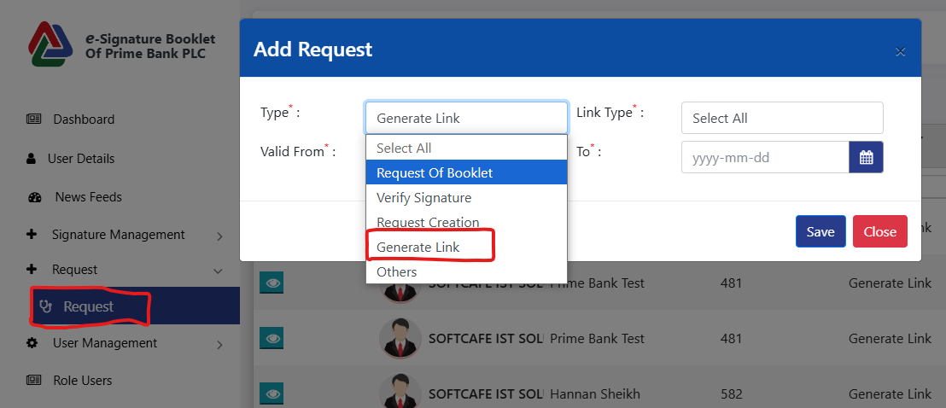

1. **Generate Link:** A user can verify any signature through the link and this link will be valid only for one time. And to create this link, select the request type Generate Link from the request section. Which is stated in section 5.6 (Request) above. It will be valid within the selected date.

**HR Module:**

**PA**

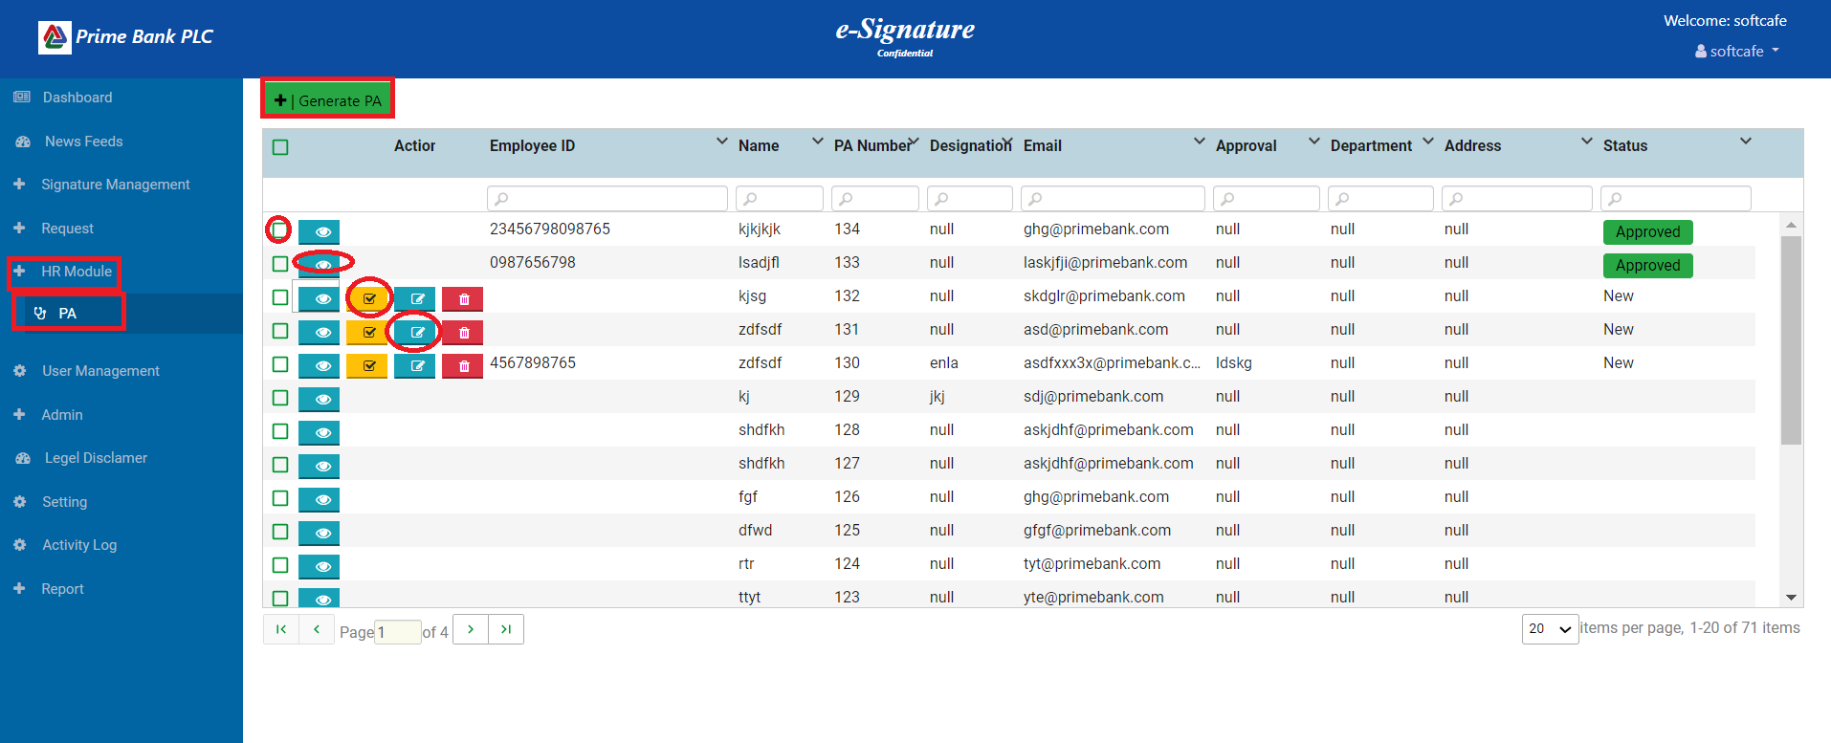

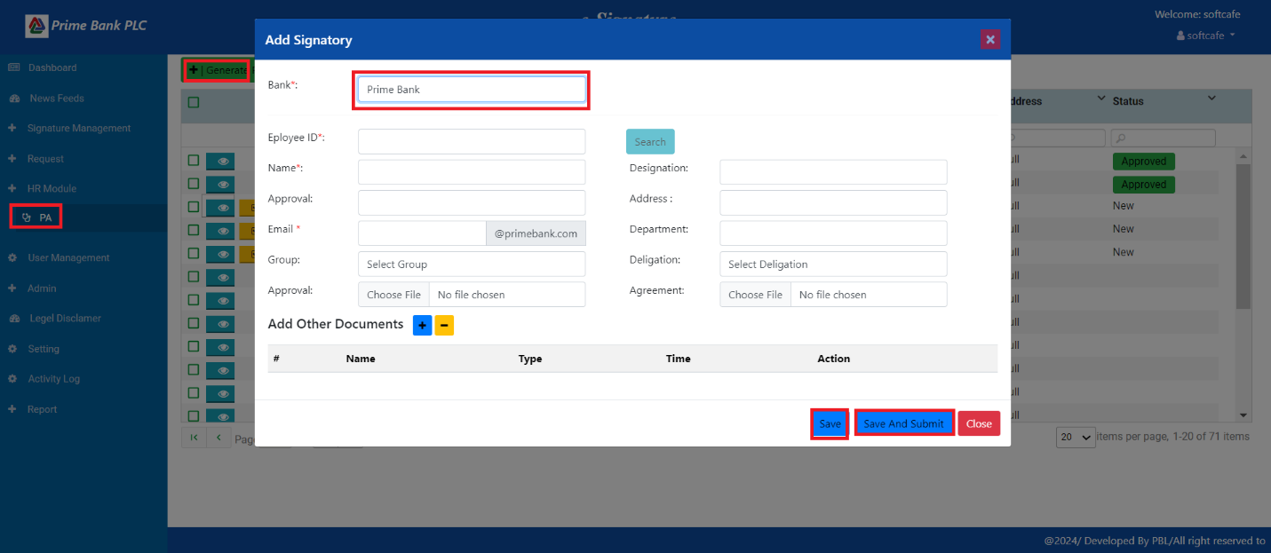

1. The user clicks on the PA menu and then clicks the Generate PA Button to open the popup. The user selects the Bank and inputs data in all fields, then clicks the save button to save the value. If the user clicks on the Save and Submit button, it will be authorized by the authorized person.

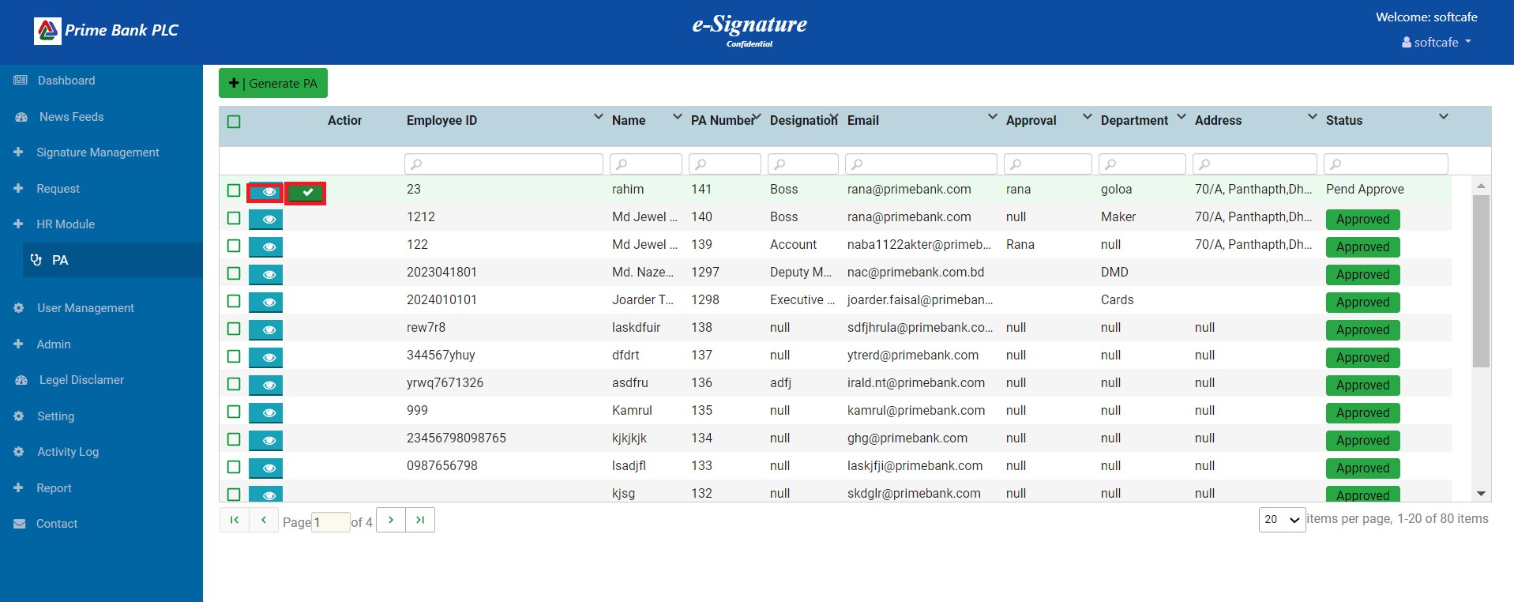

1. When the user clicks on the view icon, show the Single PA Data.
2. When the user clicks on the tick mark, an approval email is sent.

**User Management:**

**Add User**

**Internal user**

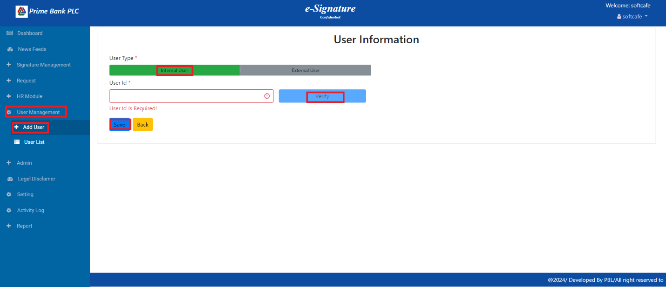

**External User**

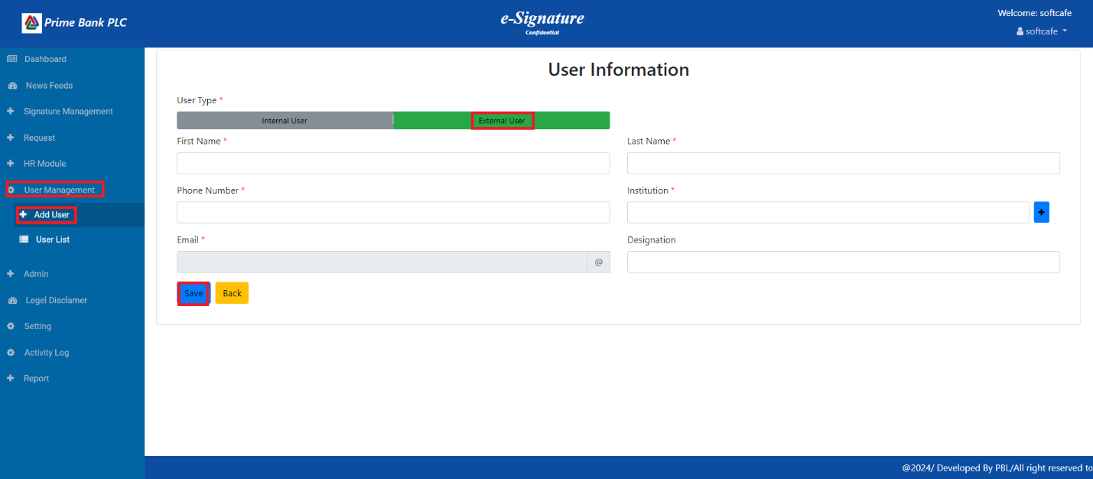

**User List:**

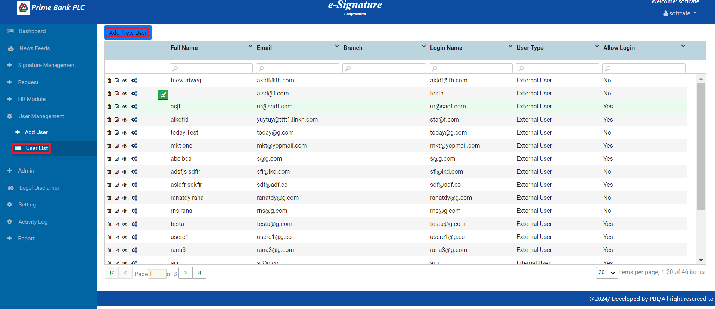

**Legel Disclamer:**

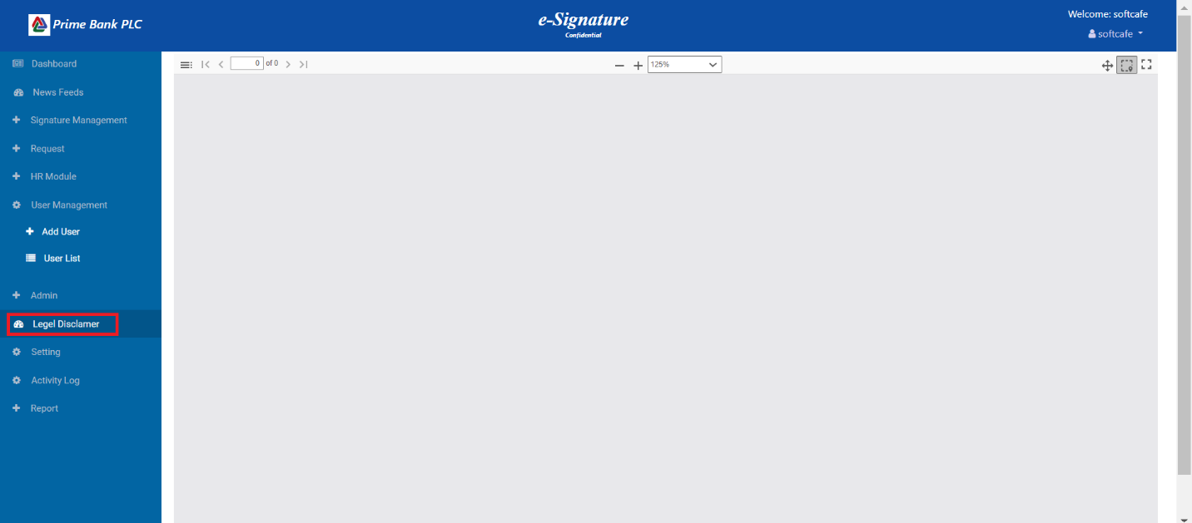

**Setting:**

**Application Config:**

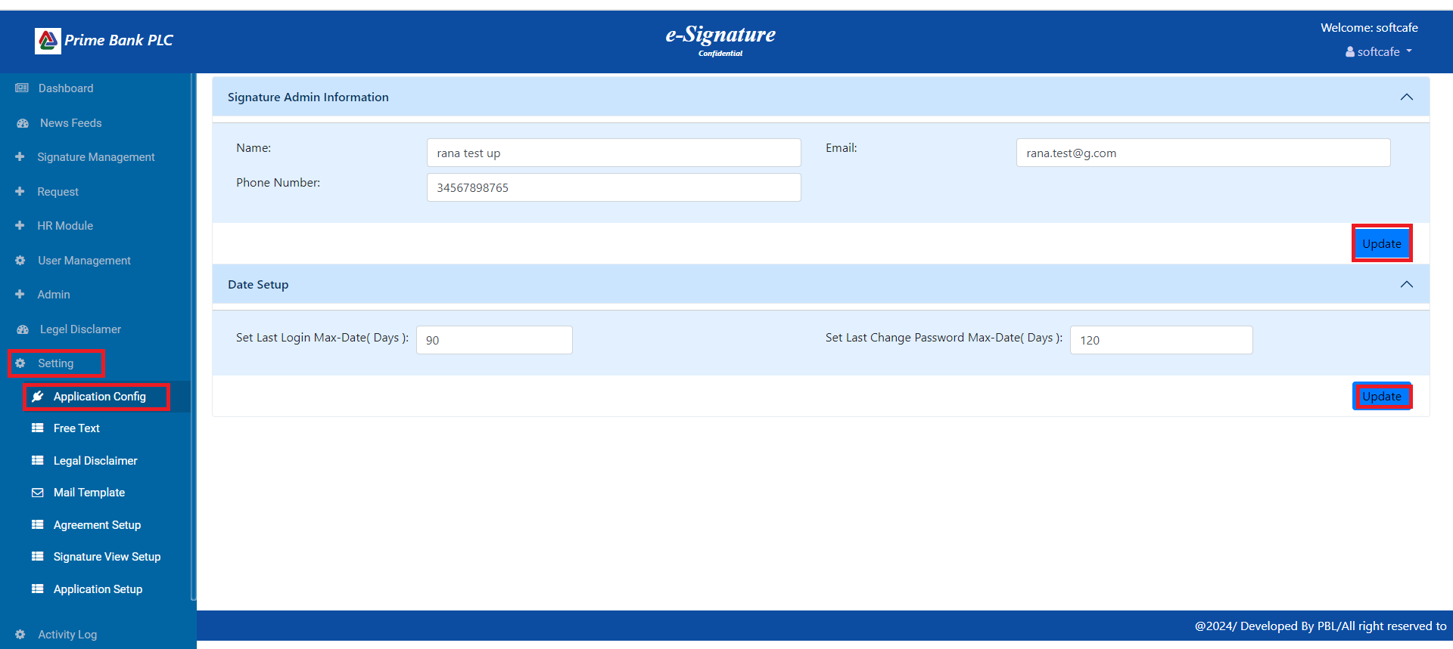

**Setting:**

**Free Text**

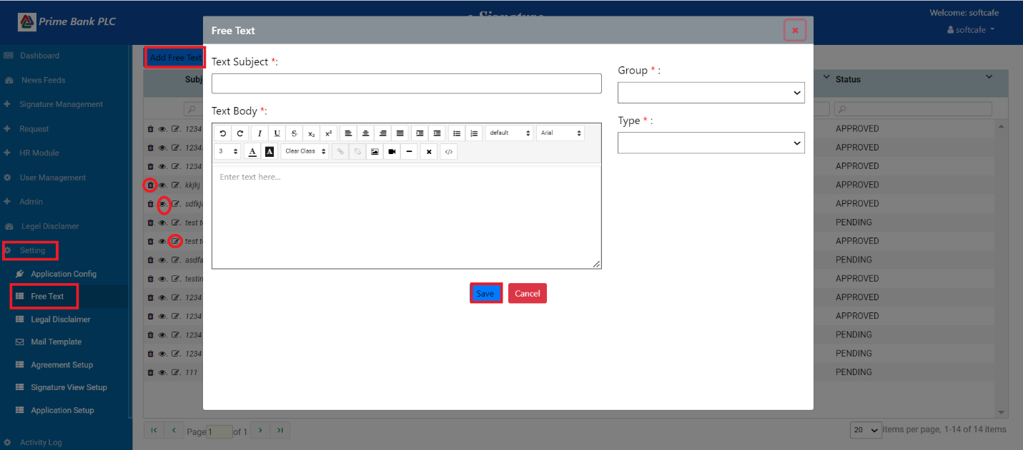

**Setting:**

**Legal Disclaimer**

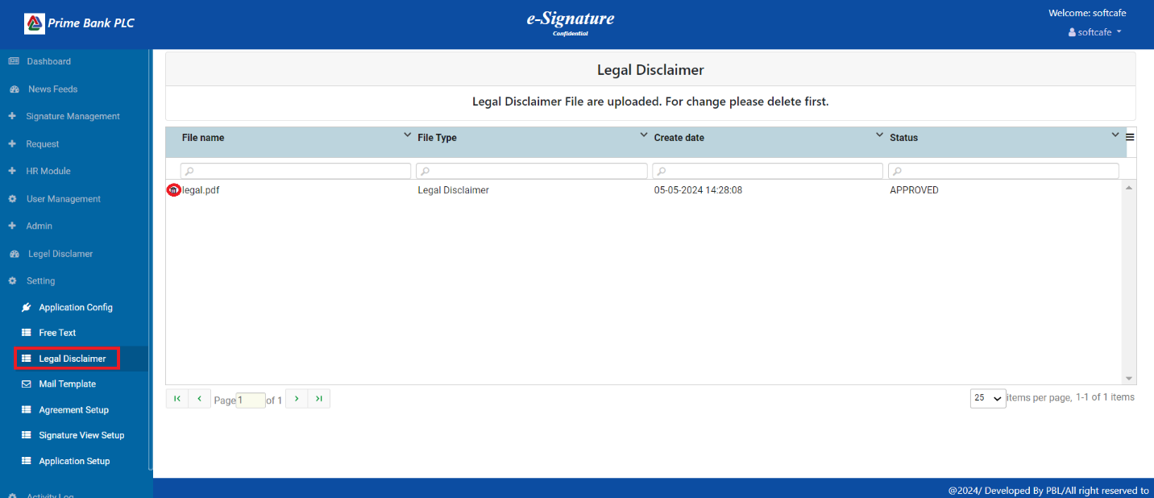

**Setting:**

**Mail Template:**

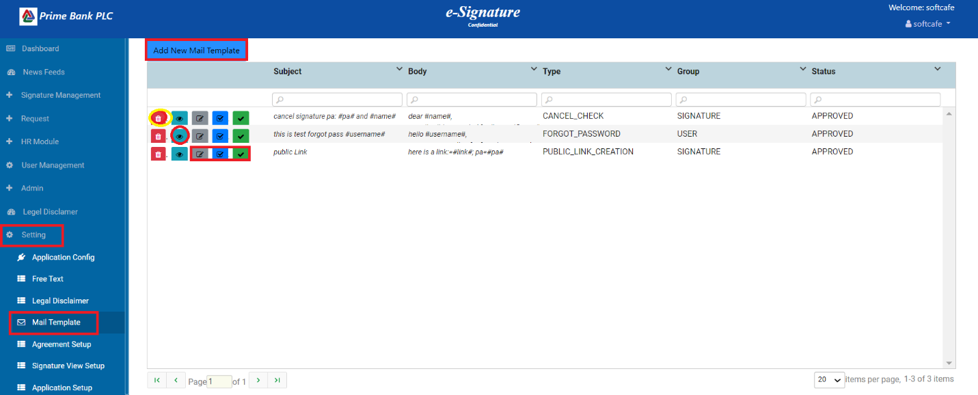

**Add New Mail Template:**

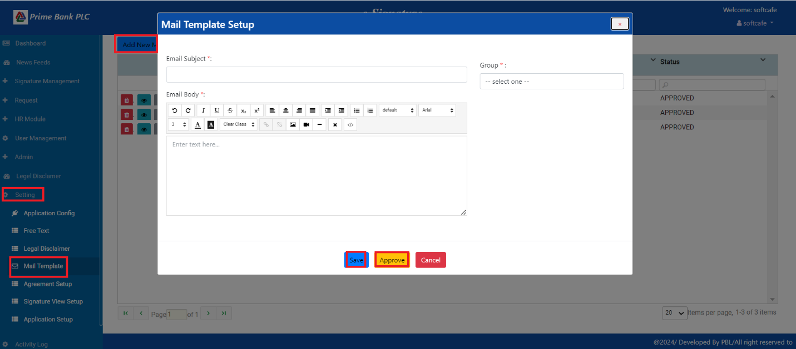

**Setting:**

**Agreement Setup**

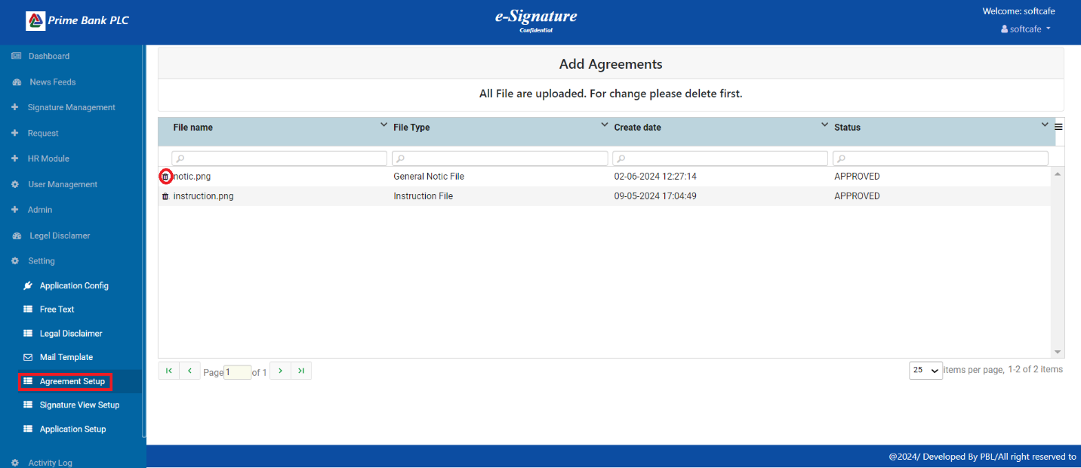

**Setting:**

**Signature View Setup:**

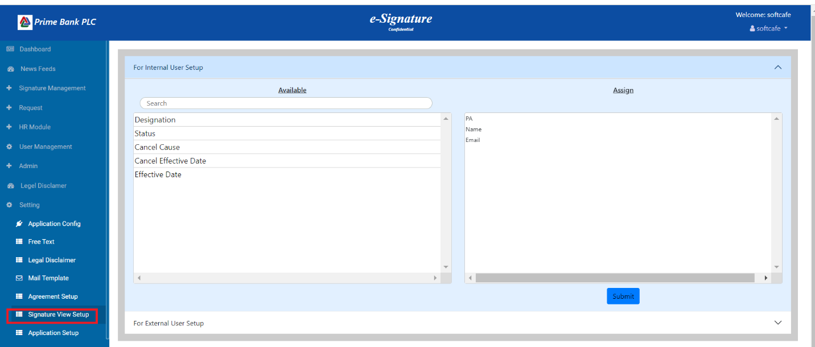

**Setting:**

**Application Setup**

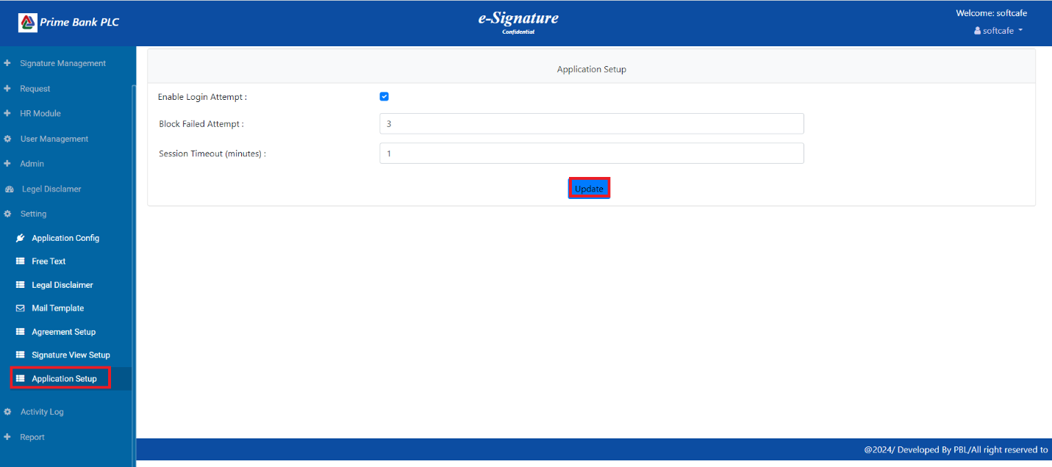

**Activity Log:**

**Logs**

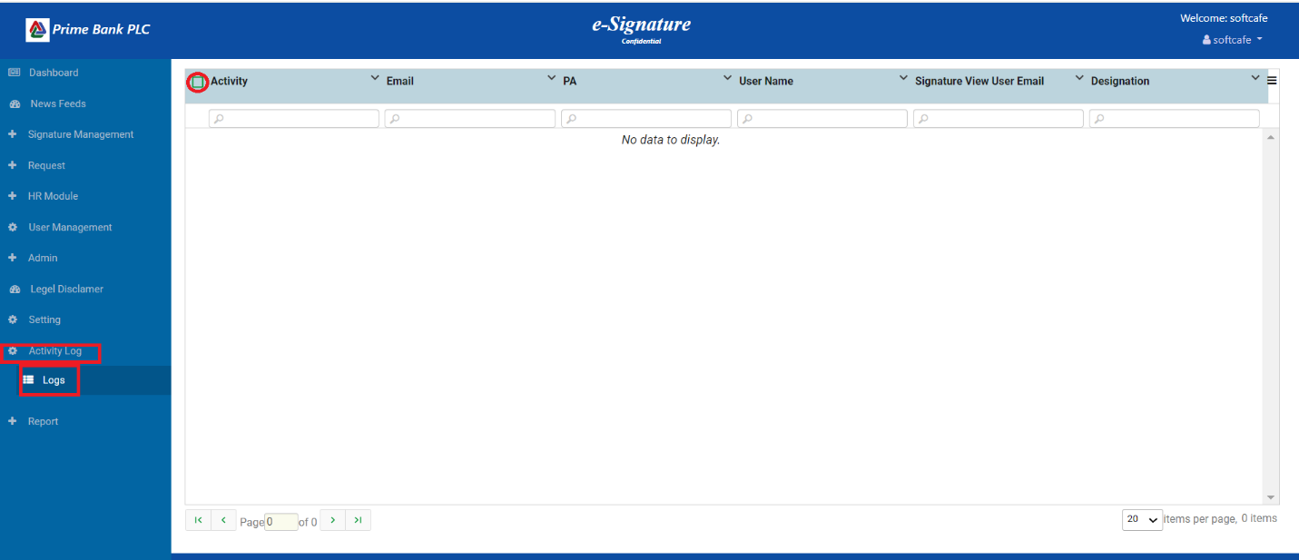

**News Feeds:**

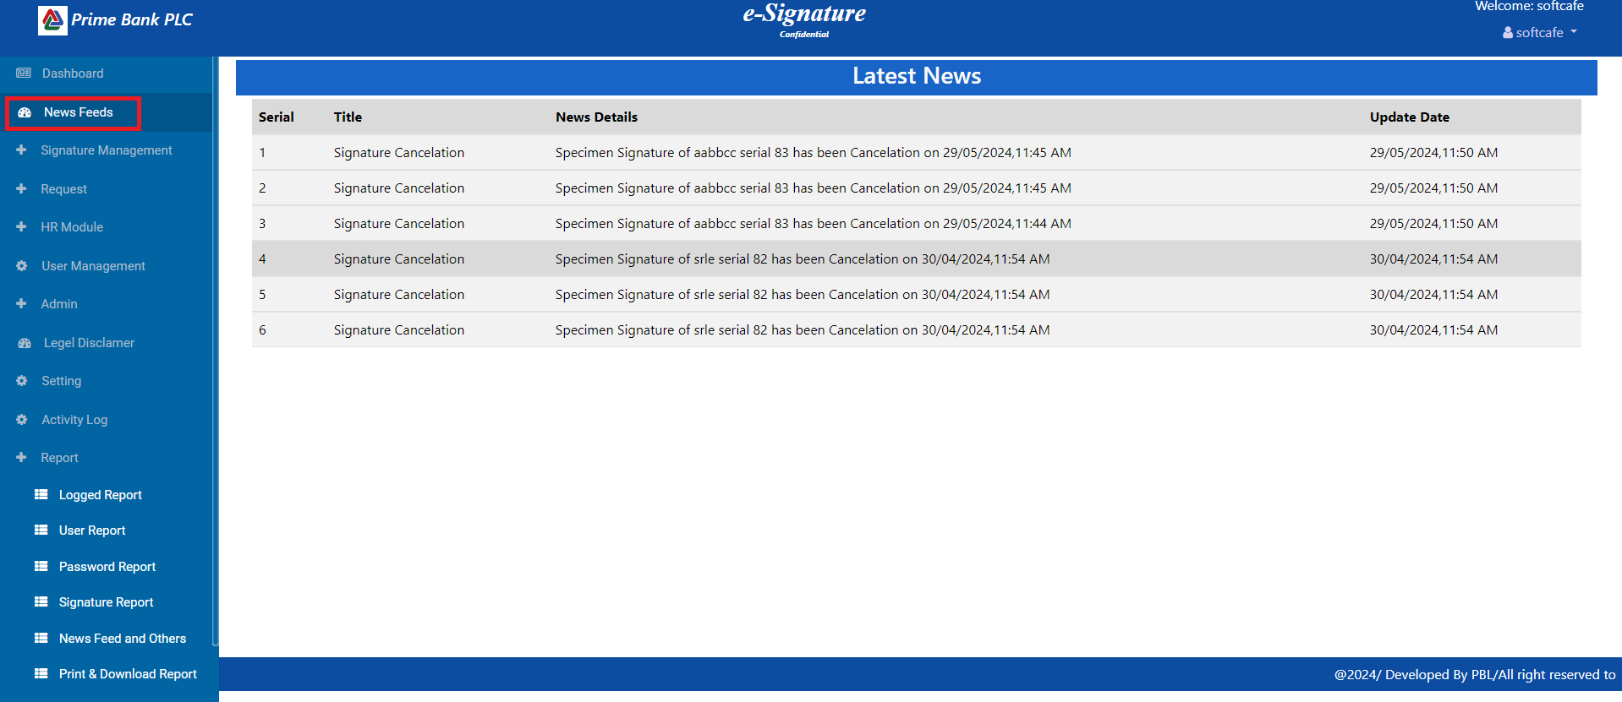

**Reports:**

1. Logged report:

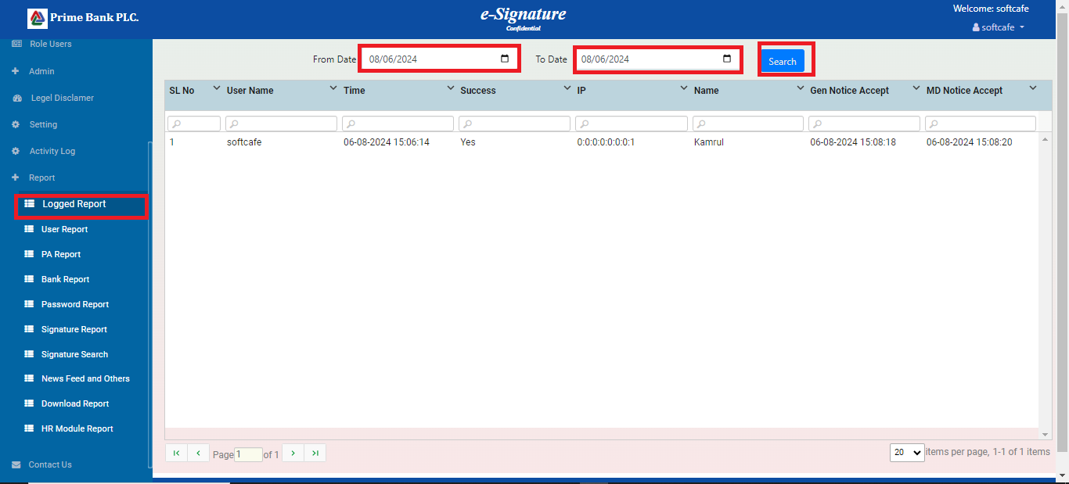

1. User report:

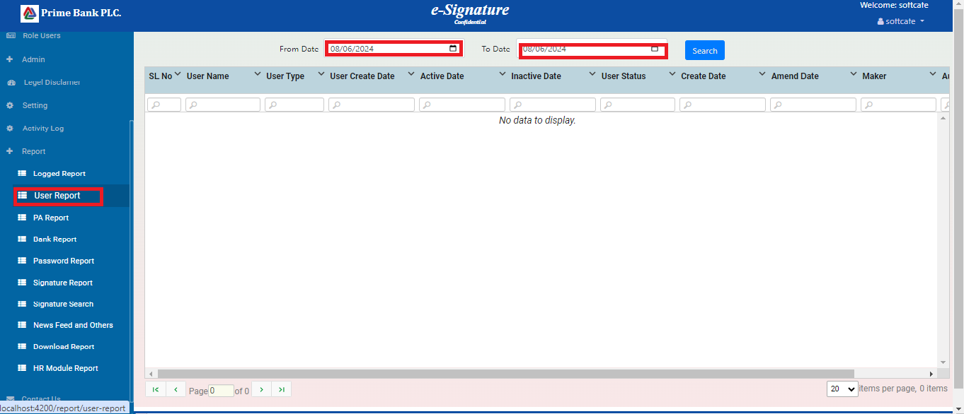

1. PA report:

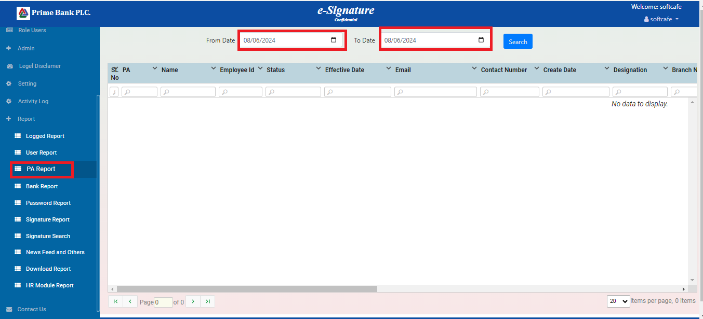

1. Bank report:

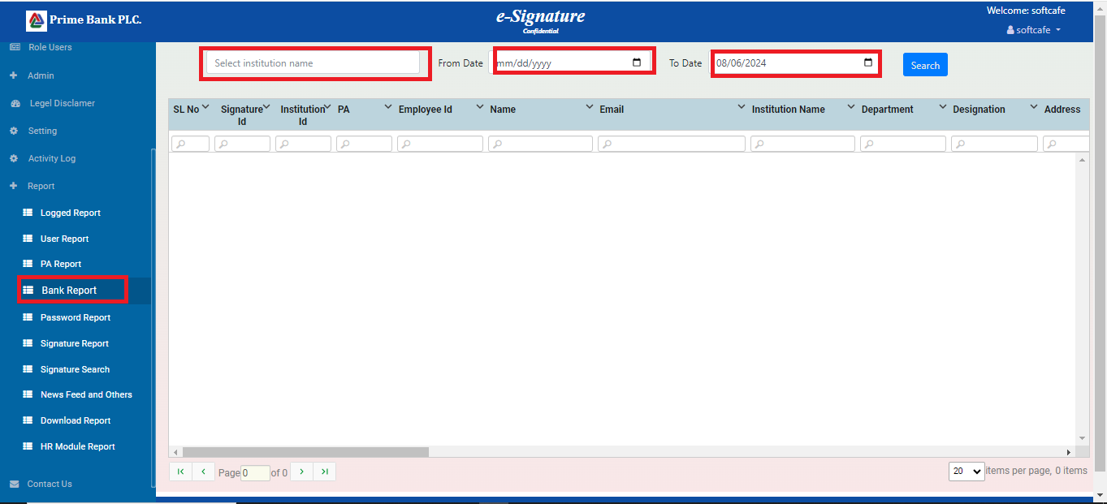

1. Password report:

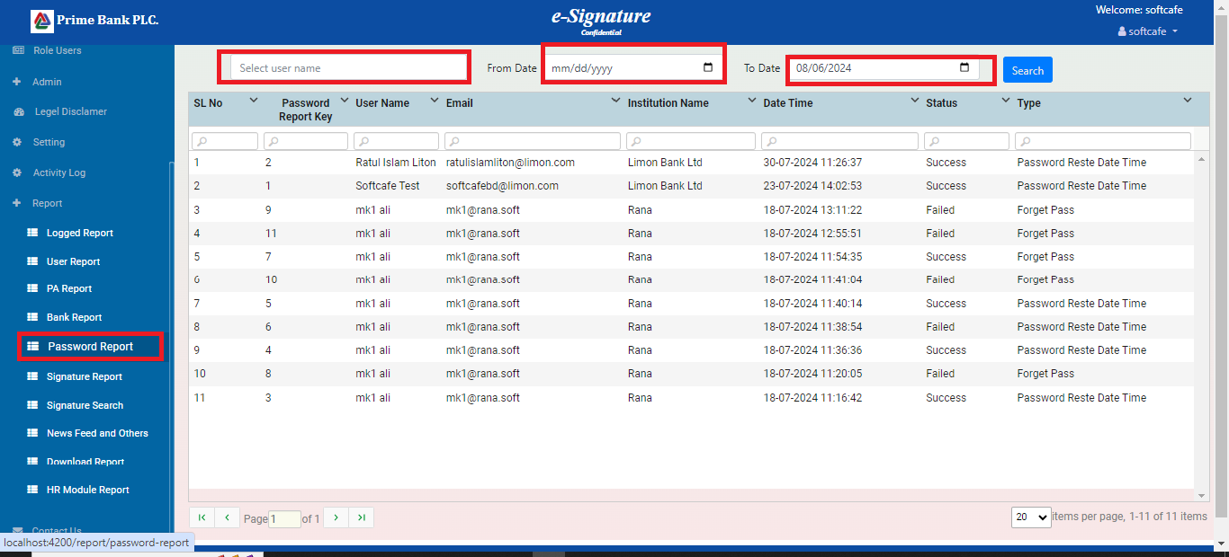

1. Signature report:

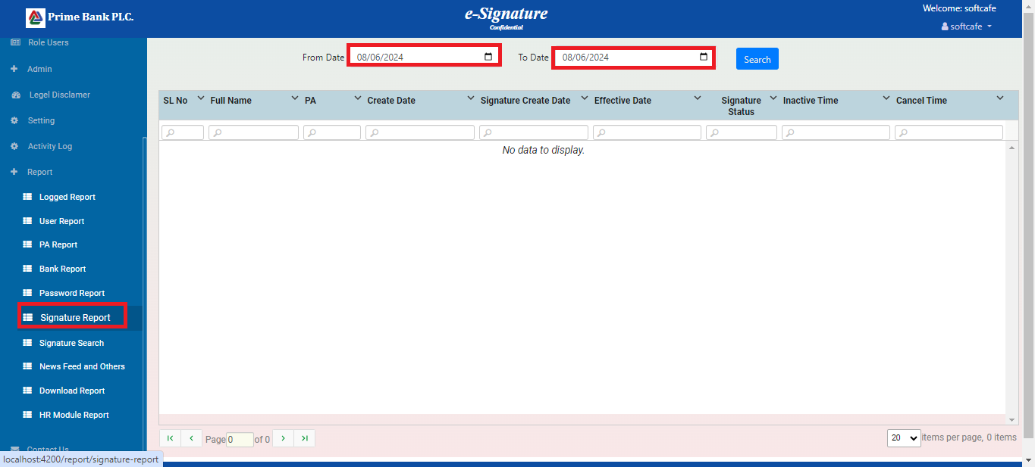

1. Signature search report:

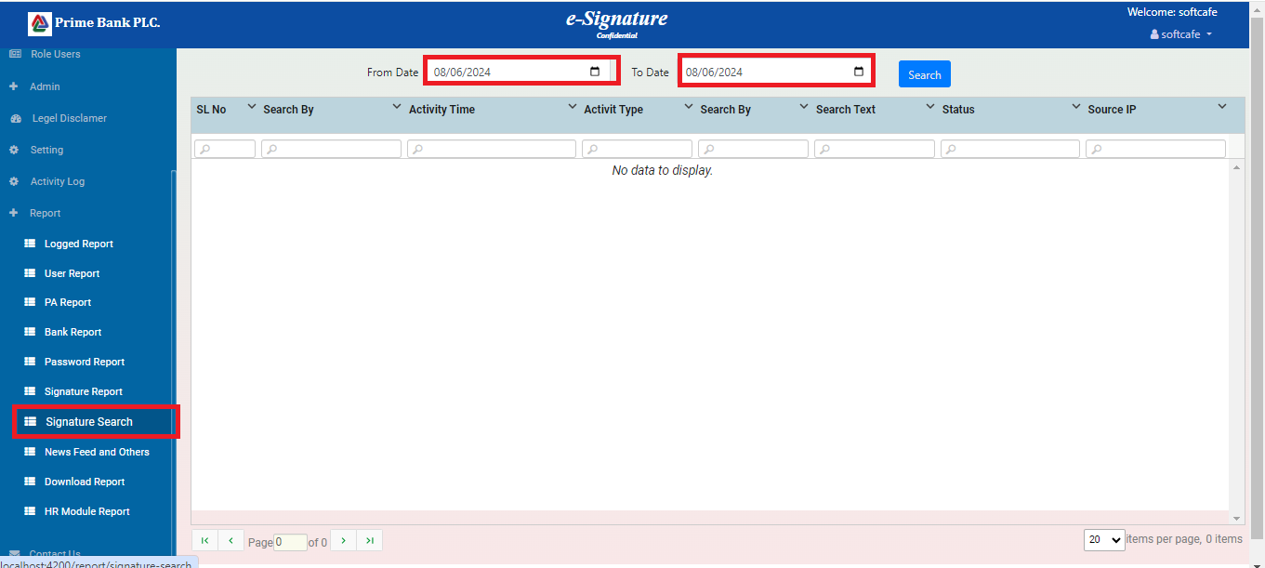

1. News feeds and others report:

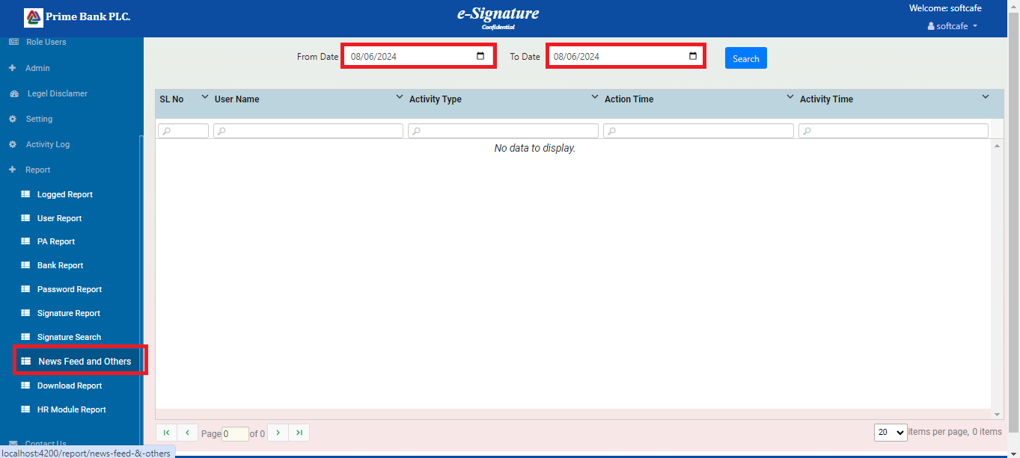

1. Download report:

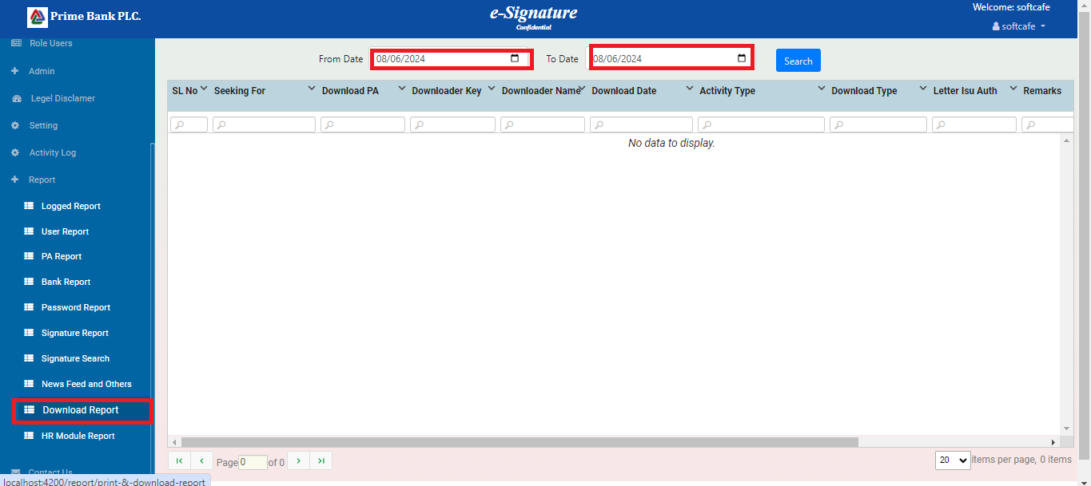

1. HR module report:

